Ministry of High Education,

Culture and Science City at Oct 6,

The High Institute of Computer Science & Information Systems



**المعهد العالي لعلوم الحاسب ونظم المعلومات**

Graduation Project:

## Emergency system using Solar panels

Assistant:

Eng. Ahmed Tammam

**Supervised By:**

Dr: Amira Gaber

Project No: 4N2426 Academic Year: 2023-2024

Ministry of High Education,

Culture and Science City at Oct 6,

The High Institute of Computer Science & Information Systems



**المعهد العالي لعلوم الحاسب ونظم المعلومات**

Graduation Project:

## Emergency system using Solar panels

Prepared By

|  |  |  |  |  |  |  |  |  |  |  |  |
| --- | --- | --- | --- | --- | --- | --- | --- | --- | --- | --- | --- |
| |  |  | | --- | --- | | ماركو بولس اسكندر -٢٠٢٠٠٦٨٦ | اسراء احمد محمد -٢٠١٩٠٨٧٤ | | ميرا نادي ميخائيل -٢٠٢٠٠٧٦٧ | شروق محمد عبد الصادق -٢٠١٩٠٦٢٥ | | مارتين شريف بطرس -٢٠٢٠٢٤٢٤ | ميرنا ممدوح ماهر - ٢٠١٩٠٦٠٢ | | محمد سميرعبد الرحمن -٢٠٢٠٣١٢٠ | هاني السيد عبد المولى -٢٠٢٠٠٥٧٢ | |  |  |  |

Assistant:

Eng. Ahmed Tammam

**Supervised By:**

Dr: Amira Gaber

Project No: 4N2426 Academic Year: 2023-2024

*Acknowledgement*

Apart from the efforts of us, the success of any project depends largely on the encouragement and guidelines of many others. We take this opportunity to express our gratitude to the people who have been instrumental in the successful completion of this project.

We would like to express our gratitude for everyone who helped us during the graduation project (Emergency system using Solar panels) starting with the endless thanks for our supervisor **Dr. Amira Gaber** who keeps encouraging us and leading us to do great job, providing our group with valuable information and advices to be better every time.

Thanks for the continuous support and kind communication which had a great effect regarding to feel interesting about what we are working on, special.

Thanks to **Prof. Dr: Ahmed Salama** who accepted our idea of this project and encourage us.

Thanks to **Eng. Ahmed Tammam** and all staff members of the high institute of computer science and information systems.

The guidance and support received from all the members who contributed and who are contributing on this project, was vital for success of the project.

We are grateful for their constant support and help.

Table of Contents

Chapter 1 Introduction 8

1. INTRODUCTION 9

1.1 Purpose: 9

1.2 Scope: 9

1.3 Related Work 10

1.4 Global Initiatives 11

1.5 Local Initiatives in Egypt 12

1.6 The Need for a Smart Emergency System 13

Chapter 2 Analysis and Design 14

2. Software Analysis 15

2.1 User Requirements: 15

2.2 System Requirement: 15

2.3 Functional Requirements 16

2.4 Non-Functional Requirements 16

System Diagrams 18

2.5 Use Case Diagram 18

2.5.2 Use Case Scenarios 19

2.6 Activity Diagram 23

2.7 Activity Diagram for logging in 24

2.8 Activity Diagram for Scanning QR code 25

2.9 Sequence Diagram 26

2.10 Context Diagram 27

2.11 Database Schema: 28

3. Hardware Analysis 29

3.1 Overview 29

3.2 System Description 29

3.3 Benefits of Solar Panel Technology in the Medical Field and Hospitals: 30

3.4 Risks of Electricity Outages in Hospitals: 31

3.5 System Block Diagram 33

3.6 Model Components 34

3.7 Wiring 36

3.8 Real life figures for the model 38

3.9 How the system works 39

3.10 Use case diagram ( For Hardware) 40

3.11 System Advantages 41

HEALTH CARD AND NFC TECHNOLOGY 42

3.12 What is the Health Card: 42

3.13 Benefits of Health Card : 42

3.14 NFC technology: 43

3.15 Benefits of NFC technology: 43

3.16 Card design and how it works: 44

3.17 Benefits of NFC technology in Health Card: 45

Chapter 3 Implementation 47

4. Software Implementation 48

1. The Patient User Interface 48

4.1.1 Launch Screen: 48

4.1.2 Registration Screen: 48

4.1.3 Interface Screen: 49

4.1.4 Profile Page: 51

4.1.5 Basic information edit Screen: 53

4.1.6 Relative/Friend information edit Screen: 53

4.1.7 Medical documents uploading Screen: 54

4.1.8 LifeLine Card Technology screen: 55

4.1.9 Solar panel system Technology screen: 55

4.1.10 About us Screen: 56

4.1.11 Find us Screen: 56

4.1.12 Contact us Screen: 57

4.13 LifeLine card data Screen: 57

2. The Admin User Interface 58

4.2.1 Admin Launch Screen: 58

4.2.2 Admin Home screen: 58

4.2.3 Search: 60

4.2.4 Admin profile screen 63

4.2.5 LifeLine Card Technology screen: 64

4.2.6 Solar panel system Technology screen: 65

4.2.7 About us Screen: 65

4.2.8 Find us Screen: 66

4.2.9 Contact us Screen: 66

3. The NFC Technology 67

4.3.1 "LifeLine card" NFC 67

Chapter 4 Future work 69

Future Work 70

Chapter 5 Conclusion 71

Conclusion 72

References 73

Tools used to develop the website 75

Appendices 76

Appendix A (MonogoDB) 77

Appendix B (NodeJS) 81

*ملخص المشروع بالغة العربية* 84

نظام الطوارئ باستخدام الألواح الشمسية 84

## **Table of figures**

|  |  |
| --- | --- |
| Figure2.1 Use Case diagram ……………………………................................ | 18 |
| Figure2.2 Registration Activity diagram …………………………………..... | 23 |
| Figure2.3 logging in Activity diagram ……………………………………… | 24 |
| Figure2.4 Scanning QR code Activity diagram ……………………………... | 25 |
| Figure2.5 Sequence diagram ………………………………………………… | 26 |
| Figure2.6 Context diagram ………………………………………………….. | 27 |
| Figure2.7 Database Scheme ............................................................................. | 28 |
| Figure2.8 System Block Diagram …………………………………………… | 33 |
| Figure2.9 Wiring …………………………………………………………….. | 36 |
| Figure2.10 Real life figures model ………………………………………….. | 38 |
| Figure2.11 Hardware Use case diagram …………………………………….. | 40 |
| Figure2.12 LifeLine Card design ……………………………………………. | 44 |
| Figure 4.1 Launch Screen …………………………………………………… | 48 |
| Figure4.2 Registration Screen ………………………………………………. | 48 |
| Figure4.3 Interface Screen …………………………………………………... | 50 |
| Figure4.4 Profile page ……………………………………………………….. | 52 |
| Figure4.5 Basic information edit Screen ……………………………………. | 53 |
| Figure4.6 Relative/Friend information edit Screen …………………………. | 54 |
| Figure4.7 Medical documents uploading Screen ……………………………. | 54 |
| Figure4.8 LifeLine Card Technology screen ………………………………... | 55 |
| Figure4.9 Solar panel system Technology screen …………………………... | 55 |
| Figure4.10 About us Screen …………………………………………………. | 56 |
| Figure4.11 Find us Screen …………………………………………………... | 56 |
| Figure4.12 Contact us Screen ……………………………………………….. | 57 |
| Figure4.13 LifeLine card data Screen ……………………………………….. | 57 |
| Figure4.14 Admin Launch Screen …………………………………………... | 58 |
| Figure4.15 Admin Home Screen ……………………………………………. | 60 |
| Figure4.16 Search Screens …………………………………………………... | 61 |
| Figure4.17 Physical edit …………………………………………………….. | 61 |
| Figure4.18 Medical edit ……………………………………………………... | 62 |
| Figure4.19 Admin profile screen ……………………………………………. | 63 |
| Figure4.20 Admin Basic info edit …………………………………………… | 64 |
| Figure4.21 LifeLine Card Technology Screen ……………………………… | 64 |
| Figure4.22 Solar panel system Technology screen …………………………. | 65 |
| Figure4.23 About us Screen …………………………………………………. | 65 |
| Figure4.24 Find us Screen …………………………………………………... | 66 |
| Figure4.25 contact us Screen ………………………………………………... | 66 |
| Figure4.26 "LifeLine card" NFC ……………………………………………. | 67 |
| Figure4.27 Admin editing patient med info …………………………………. | 67 |
| Figure4.28 NFC&QR Scanning result ………………………………………. | 68 |
| Figure4.29 NFC Data ………………………………………………………... | 68 |

**Abstract**

Accidents and critical health conditions can happen everywhere, as such, patients need proper and immediate medical attention at any sudden time, currently, Hospitals take a long time to examine patients, which can create issues for patients and emergency staff, to facilitate the doctor's process in treating patients by solving the time wasted in emergency hospitals. NFC chip card with the medical history of its holder to assure that the patient will be treated appropriately according to his health condition Additionally, emergency cases, such as operating rooms and intensive care, require renewable energy sources like solar energy.

# Chapter 1 Introduction

## 1. INTRODUCTION

Nowadays, health awareness is not only a growing trend among countries but also among individuals, and with the great development in technology, a health care card system is required. “Suppose you are a person with chronic diseases of any kind and you are ill or have a traffic accident, wouldn't it be better if you had a health care card with your medical history on it?” This is what our system focuses on, doctors can easily know your medical history through it. If you suffer from chronic diseases such as diabetes, heart disease, cancer, and arthritis. They can also know your blood type, through the card you carry with you which is supported by an ambulance number, and secured with a PIN code to avoid any unverified alterations.

### 1.1 Purpose:

The purpose of the system is to facilitate the doctor's process of treating patients in terms of the ability to make quick treatment decisions that directly affect the patient's life. The main purpose of the system is to solve the wasted time in misdiagnosing patients by doctors in emergency and hospitals and to use renewable energy sources such as solar energy because it is safe, renewable and permanent in intensive care units and nurseries.

### 1.2 Scope:

* Manually updating the general medical system into an application and website so that the user can know the details of his medical history, chronic diseases and old prescriptions at any time from his phone via application or browser
* The healthcare card system provides information such as blood type, chronic diseases, routine medications, personal information and emergency contacts.
* We will provide renewable energy, namely solar panels, which will be used in cases of power outages.

### 1.3 Related Work

The integration of Near Field Communication (NFC) technology in healthcare has seen significant growth due to its potential to streamline access to critical patient information during emergencies. Several studies and projects have demonstrated the effectiveness and practicality of using NFC for various medical applications.

NFC technology has been successfully implemented in various healthcare settings to improve patient care and operational efficiency. A study by Kim et al. (2020) explored the use of NFC to access electronic health records (EHRs), enabling healthcare providers to quickly retrieve patient information and reducing the time needed to make informed medical decisions during emergencies. This study highlighted the benefits of NFC in enhancing patient safety and care quality by providing immediate access to accurate medical histories.

In emergency medical services, accurate and rapid patient identification is crucial. Traditional methods, such as verbal confirmation and ID checks, can be time-consuming and error-prone, especially when the patient is unconscious or unable to communicate. A pilot program by Patel et al. (2019) demonstrated the effectiveness of NFC-enabled wristbands in such scenarios. The study showed that EMTs could scan an NFC card on a patient’s wristband to instantly access vital medical information, such as allergies, current medications, and medical history, significantly improving the response time and appropriateness of care provided.

Wearable devices and technologies have been increasingly used to monitor and manage health conditions. A project by Hernandez et al. (2021) introduced a wearable medical alert system using NFC technology integrated into smartwatches. This system allowed users to store their medical data on a secure server, accessible via an NFC-enabled smartwatch. The study found that this approach provided an effective means of delivering crucial medical information to first responders and healthcare providers during emergencies.

### 1.4 Global Initiatives

* World Health Organization (WHO):

The WHO has consistently emphasized the importance of leveraging technology to improve healthcare outcomes. Their guidelines on digital health include recommendations for the use of technologies like NFC to streamline patient data access in emergencies. The WHO's push for electronic health records (EHRs) and integrated health systems provides a strong foundation for the adoption of NFC-based solutions globally.

* European Union eHealth Action Plan:

The EU eHealth Action Plan outlines strategies to improve healthcare through digital solutions. One of the key objectives is to ensure that medical information is available across borders, which aligns with the use of NFC cards for accessing patient data. Several EU-funded projects have explored the use of NFC and other smart technologies in emergency medical settings to enhance patient care.

* United States Health Information Technology for Economic and Clinical Health (HITECH) Act:

In the US, the HITECH Act has driven the adoption of EHRs and other digital health technologies. Various studies and pilot programs have demonstrated the effectiveness of using NFC and similar technologies to provide immediate access to patient information, thereby improving emergency response and patient outcomes.

* Australia’s My Health Record:

Australia's national digital health record system, My Health Record, aims to provide a comprehensive, accessible repository of patient data. Initiatives within this system have explored the integration of NFC technology to facilitate quick access to medical records, particularly in emergency situations.

### 1.5 Local Initiatives in Egypt

* **Egyptian Ministry of Health and Population:**

The Ministry has been actively pursuing digital health initiatives to improve healthcare delivery. Their efforts to digitize health records and create a national health information system highlight the potential for integrating NFC technology to enhance emergency medical services.

* **Cairo University Hospitals:**

Research and pilot programs at Cairo University Hospitals have explored the use of smart technologies, including NFC, to manage patient information. These initiatives have shown promising results in improving the speed and accuracy of accessing patient data during emergencies.

* **Ain Shams University Specialized Hospital:**

Ain Shams University has been involved in projects aimed at improving healthcare through technology. Their work on developing and implementing digital health solutions includes exploring NFC technology to streamline the process of retrieving patient medical histories in critical situations.

* **Private Healthcare Providers:**

Several private healthcare providers in Egypt, such as Cleopatra Hospitals Group and As-Salam International Hospital, have been investing in digital health solutions. These institutions recognize the importance of quick access to patient information and are exploring the use of NFC and other smart technologies to enhance their emergency services.

### 1.6 The Need for a Smart Emergency System

Globally and locally, there is a growing recognition of the need for smart emergency systems that can provide immediate access to patient medical histories. Key drivers for this need include:

* **Rapid Response:**

In emergency situations, time is critical. Access to accurate and comprehensive patient information can significantly reduce response times and improve treatment outcomes. NFC technology offers a quick and reliable means of accessing this information.

* **Accuracy and Safety:**

Miscommunication or lack of information can lead to medical errors. A smart emergency system ensures that healthcare providers have accurate data at their fingertips, reducing the risk of errors and enhancing patient safety.

# Chapter 2 Analysis and Design

## 

## 2. Software Analysis

### **2.1 User Requirements:**

1. The Lifeline website system allows patients to preview their own profiles.
2. The system enables patients to enter and update their personal information.
3. Patients can input and update their medical tests and x-ray results.
4. The system allows patients to review their complete medical history.
5. The Lifeline website system provides each patient with an NFC card containing all their personal and medical information, ensuring quick and easy access for efficient healthcare management.
6. Hospitals will provide intensive care using solar systems to maintain patient security during power outages.

Top of Form

### **2.2 System Requirement:**

* 1. - the first time, each patient will add this personal information.
  2. - System shall automatically check the stored data and represent it to user.
  3. - System shall automatically store that data in a located data store.

and reliable results within a short time To speed up the process of diagnosing and treating the patient's condition.

1. the admin (Doctor)can access a patient's medical information by searching for their national ID.
2. After verifying the accuracy of all data, each patient will receive their own NFC card containing stored personal and medical information. The system will automatically retrieve and display this information on the website and NFC.

### **2.3 Functional Requirements**

* **Patient Registration:**

**- Create account**

**- Login into system As user**

**- Fill the require data**

**- Save Personal data**

* **2.3.2 Admin Registration:**

**- Will have administrator account from his/her hospital.**

**- Login into system As Admin.**

**- Fill the require data**

**- Capture and store patient medical information.**

**- Verify insurance details and update records.**

**- Generate a unique patient identifier (NFC Card).**

### 2.4 Non-Functional Requirements

* Usability Requirement

The system shall allow the users to access the system from the phone using android application and from the pc using website. The system uses a website and android application as an interface. Since all users are familiar with the general usage of mobile app, no special training is required. The system is user friendly which makes the system easy.

* **Availability Requirement**

The system is available 100% for the user and is used 24 hrs a day and 365 days a year. The system shall be operational 24 hours a day and 7 days a week.

* **Efficiency Requirement**

Mean Time to Repair (MTTR) - Even if the system fails, the system will be recovered back up within an hour or less. • Accuracy The system should accurately provide real time information taking into consideration various concurrency issues. The system shall provide 100% access reliability.

* **Performance Requirement**

The information is refreshed depending upon whether some updates have occurred or not in the application or in the website. The system shall respond to the member in not less than two seconds from the time of the request submittal. The system shall be allowed to take more time when doing large processing jobs. Responses to view information shall take no longer than 5 seconds to appear on the screen.

* **Reliability Requirement**

The system has to be 100% reliable due to the importance of data and the damages that can be caused by incorrect or incomplete data. The system will run 7 days a week, 24 hours a day.

## **System Diagrams**

### 2.5 Use Case Diagram

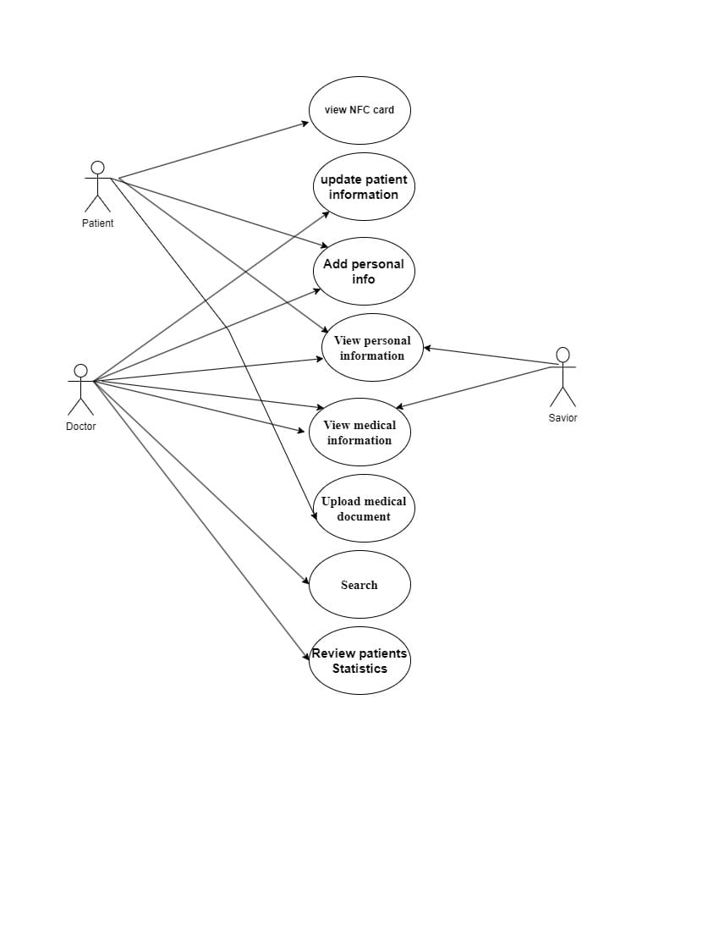

Figure2.1 Use Case diagram

### 2.5.2 Use Case Scenarios

|  |  |
| --- | --- |
| Name | Patient |
| Description | This use case is to create a new account and store its information in the database so user can log in the next time without entering all of his information again |
| Actors | Patient, Doctor |
| Precondition | Having a valid e-mail |
| Main Flow | * Enter the website and choose register * Enter name, password, e-mail, age and gender * Reenter password to check similarity * Log in the website |
| Post Condition | Have an account |

|  |  |
| --- | --- |
| Name | Administrator |
| Description | This use case is to enter your profile and use the capabilities of website |
| Actors | Patient, Doctor |
| Precondition | Having an account (Registered before) |
| Main Flow | * Enter username and password * Website will validate this information * Enter website if password is correct |
| Post Condition | Get to homepage to use the website |
| Name | Scan QR |
| Description | This use case is get to the website but from the NFC tag to view medical an personal information |
| Actors | Patient, Doctor, viewer |
| Precondition | Having an account that is connected to the NFC tag |
| Main Flow | * Scan the NFC tag using RFID reader * Get the link provided by NFC tag * Open from any browser * View personal and medical information |
| Post Condition | Have NFC tag linked to a valid account |

|  |  |
| --- | --- |
| Name | Add personal information |
| Description | This use case is made to add personal information like age, gender, relatives, and any other personal data |
| Actors | Patient, Doctor |
| Precondition | Having an account in the database |
| Main Flow | * Log in * Go to profile page * Click on add personal information * Add required information in its fields * Click on save * Data saved in database |
| Post Condition | Having more data about the user in database |
| Name | View Personal Information |
| Description | This use case is to show the data about user that is already saved before in the data base |
| Actors | Patient, Doctor |
| Precondition | Having an account |
| Main Flow | * Log in * Go to home screen * Click in profile * Choose view personal information |

|  |  |
| --- | --- |
| Name | View Medical Information |
| Description | This use case is made to show any medical information or medical documents that is already uploaded before about the patient |
| Actors | Patient, Doctor, Viewer |
| Precondition | Having Account with the medical information uploaded before |
| Main Flow | * Log in to your account * Choose view medical information * Open any document to know about patient |

|  |  |
| --- | --- |
| Name | Upload Medical Document |
| Description | This use case is made to allow for the user the capability to upload a document like x-ray or scans or any lab results |
| Actors | Patient |
| Precondition | Having an account |
| Main Flow | * Log in to a valid account * Go to home page * Click on profile * Choose upload document * Upload document and name it * Click on submit |
| Post Condition | Document stored in database |

|  |  |
| --- | --- |
| Name | Search |
| Description | This use case is made to search in the website about a patient or a doctor |
| Actors | Doctor |
| Precondition | Having an account |
| Main Flow | * Log in to your account * Go to home screen * Press on search * Type |

### 2.6 Activity Diagram

Activity diagram for registration

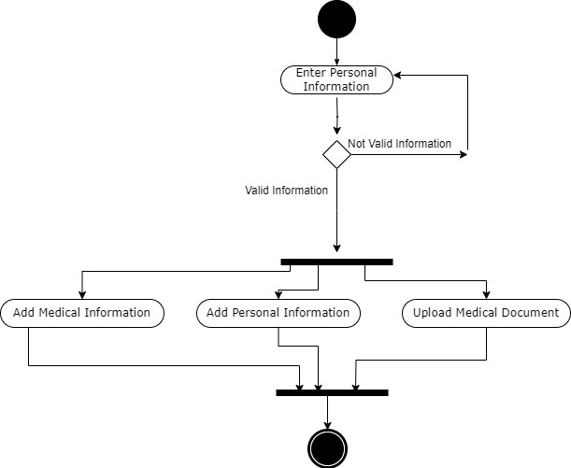

Figure2.2 Registration Activity diagram

### 2.7 Activity Diagram for logging in

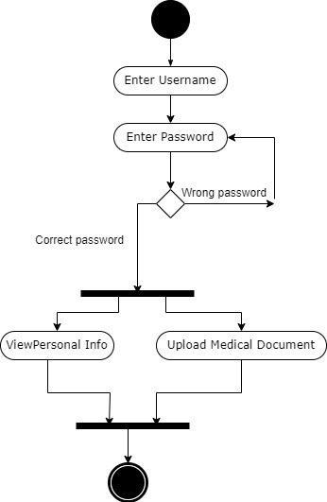

Figure2.3 logging in Activity diagram

### 2.8 Activity Diagram for Scanning QR code

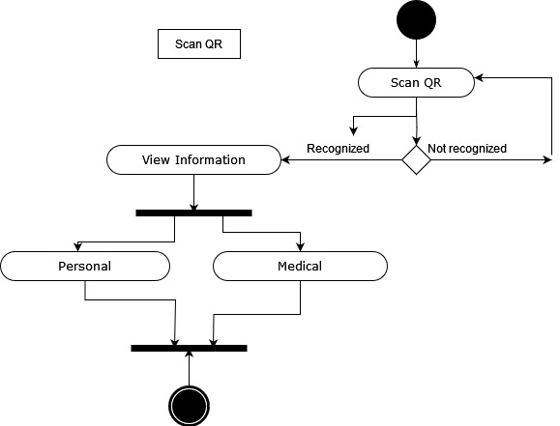

Figure2.4 Scanning QR code Activity diagram

### 2.9 Sequence Diagram

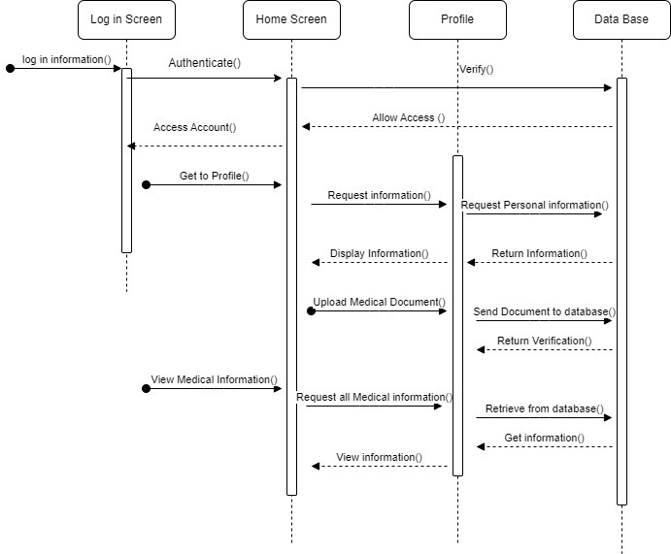

Figure2.5 Sequence diagram

### 2.10 Context Diagram

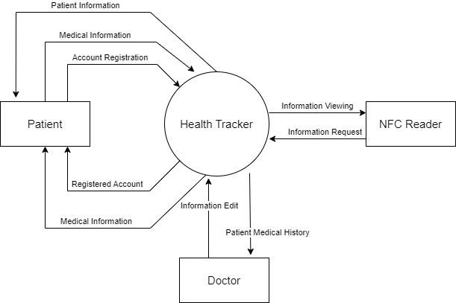

Figure2.6 Context diagram

### 2.11 Database Schema:

* **No SQL Database:**

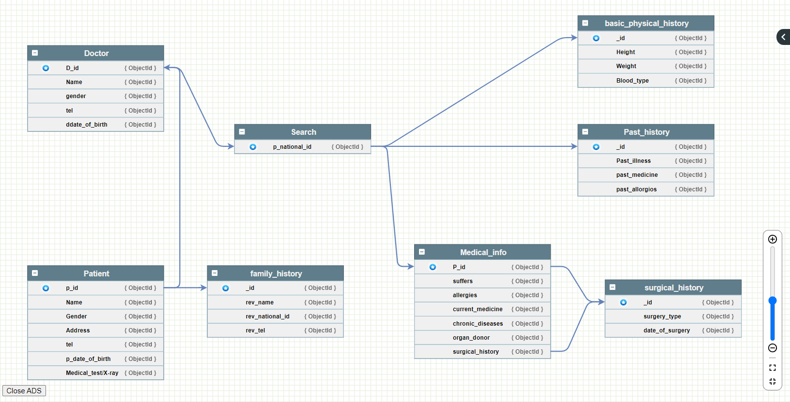

Figure2.7 Database Scheme

## 3. Hardware Analysis

**(Emergency System Using Solar Panels)**

### 3.1 Overview

This model aims to develop a reliable and sustainable energy solution for hospitals in Egypt, addressing the critical issue of frequent electrical power outages. These outages have indirectly caused fatalities in hospitals and other unsecured locations. To mitigate this problem, the project proposes using solar energy as an alternative power source, focusing on hospitals, nurseries, and intensive care units.

### 3.2 System Description

The proposed system ensures a stable and safe energy supply by harnessing solar power, which is abundant in Egypt and the Middle East due to the region's sunny climate for most of the year. The system features a solar energy tracking model, equipped with optical sensors positioned at strategic corners. These sensors facilitate the continuous tracking of the sun's movement throughout the day

The tracking mechanism is powered by a set of mathematical equations designed to optimize the orientation of the solar panels, maximizing their exposure to sunlight. This optimization ensures that the solar panels capture the maximum amount of solar energy available each day.

### 3.3 Benefits of Solar Panel Technology in the Medical Field and Hospitals:

**1. Reliable Power Supply:**

* Continuous Operations: Solar panels provide a consistent and reliable source of electricity, ensuring that critical medical equipment and life-saving devices remain operational even during power outages.
* Emergency Preparedness: Hospitals can maintain essential services and respond effectively during emergencies or natural disasters, where power outages are more likely to occur.

**2. Cost Savings:**

* Reduced Energy Bills: Solar energy can significantly reduce the operating costs of hospitals by lowering electricity bills, allowing more funds to be allocated to patient care and medical resources.
* Long-Term Investment: The initial investment in solar panels pays off over time through savings on energy costs and potential government incentives or subsidies.

**3. Environmental Benefits:**

* Reduced Carbon Footprint: Solar energy is a clean, renewable source of power that reduces greenhouse gas emissions and minimizes the environmental impact of hospital operations.
* Sustainability: Utilizing solar power supports the hospital's commitment to sustainability and public health by reducing reliance on fossil fuels.

**4. Energy Independence**:

* Self-Sufficiency: Hospitals can achieve greater energy independence, reducing their vulnerability to external power grid failures and price fluctuations in the energy market.
* Scalability: Solar power systems can be scaled to meet the growing energy needs of hospitals as they expand their facilities and services.

### 3.4 Risks of Electricity Outages in Hospitals:

**1. Life-Threatening Situations:**

* Critical Equipment Failure: Power outages can cause life-support systems, ventilators, dialysis machines, and other critical medical equipment to fail, posing severe risks to patients' lives.
* Surgery Interruptions: Interruptions during surgical procedures due to power outages can lead to catastrophic outcomes, including complications or fatalities.

**2. Compromised Patient Care:**

* Medication Storage: Power outages can affect refrigeration systems used to store temperature-sensitive medications and vaccines, leading to spoilage and potential health risks.
* Data Loss: Electronic health records (EHR) systems may become inaccessible, causing delays in patient care and difficulties in accessing vital medical information.

**3. Operational Disruptions:**

* Diagnostic Delays: Imaging equipment like MRI, CT scanners, and X-ray machines require stable power. Outages can delay diagnoses and treatment plans.
* Communication Breakdowns: Power failures can disrupt communication systems within the hospital, hampering coordination among medical staff and emergency response teams.

**4. Financial Impact:**

* Increased Costs: Hospitals may incur additional costs for emergency power solutions, equipment repairs, and operational disruptions caused by power outages.
* Reputation Damage: Frequent power outages can damage a hospital's reputation, leading to a loss of trust among patients and the community.

### 3.5 System Block Diagram

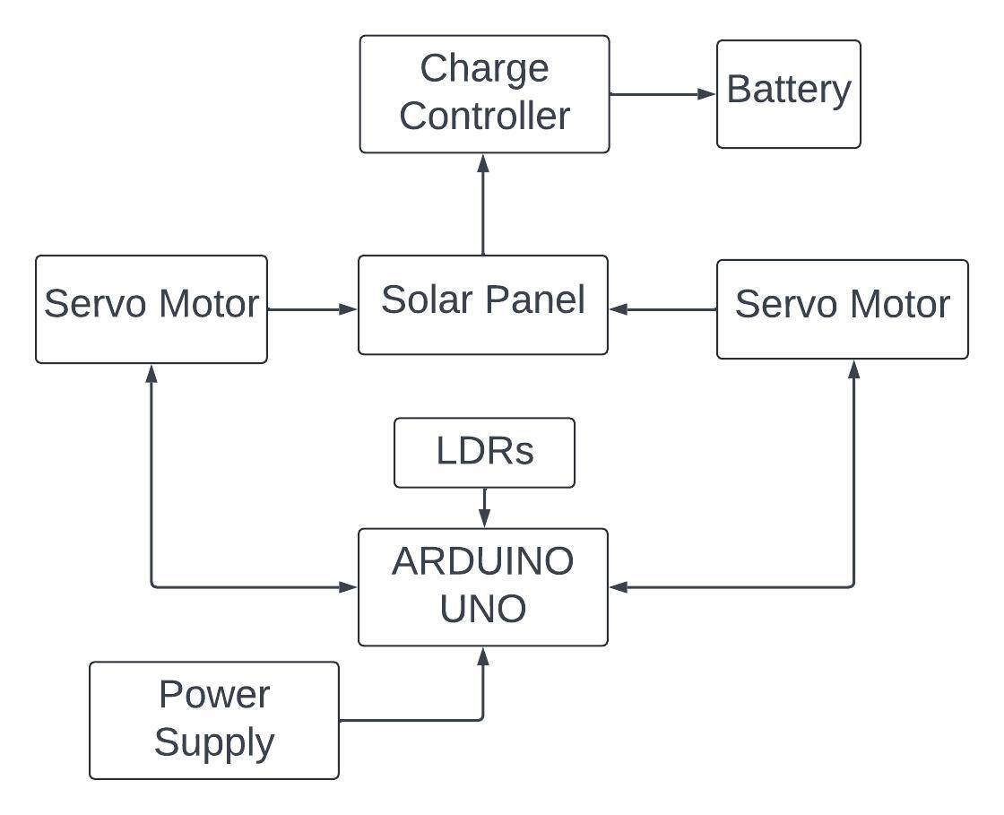

Figure2.8 System Block Diagram

* Power Supply:
  + Provides power to the Arduino UNO.
* Arduino UNO:
  + Receives power from the power supply.
  + Connects to Light Dependent Resistors (LDRs) to detect sunlight intensity.
  + Controls Servo Motors based on LDR inputs to adjust the Solar Panel's position.
* LDRs (Light Dependent Resistors):
  + Send sunlight intensity data to the Arduino UNO.
* Servo Motors:
  + Adjust the orientation of the Solar Panel based on commands from the Arduino UNO.
* Solar Panel:
  + Converts sunlight into electrical energy.
* Charge Controller:
  + Receives electrical energy from the Solar Panel.
  + Manages the charging of the Battery.
* Battery:
  + Stores electrical energy for later use.
  + Connected to the Charge Controller.

### 3.6 Model Components

* 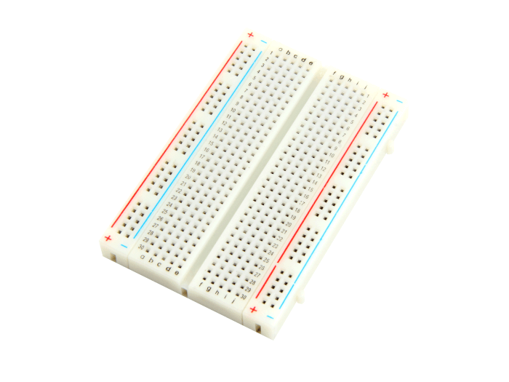BB-801 Breadboard
* Used for building temporary circuits. It is useful to designers because it allows components to be removed and replaced easily
* 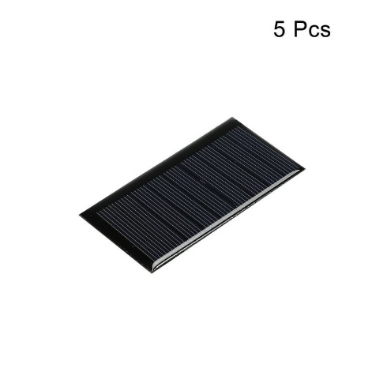Mini Solar Panel 1.5 Watt, 6V/250mA
* Used to power small appliances, charge electronic devices like phones, and provide energy for outdoor activities

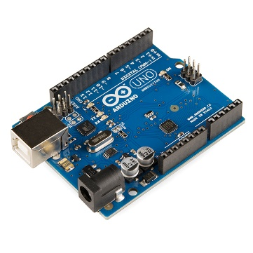

* Arduino UNO, Rev3 - Clone
* Open-source microcontroller board that can be integrated into a variety of electronic projects.

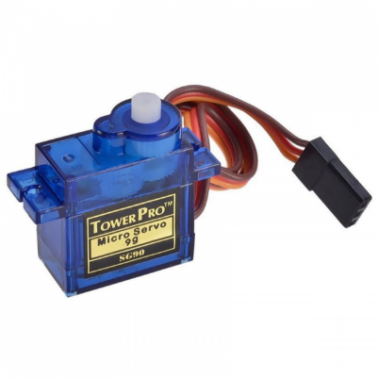

* SG90 Micro Servo Motor180°
* This type of servo motor can rotate to a specific angle (usually between 0 and 180 degrees) and hold that position with high accuracy.
* 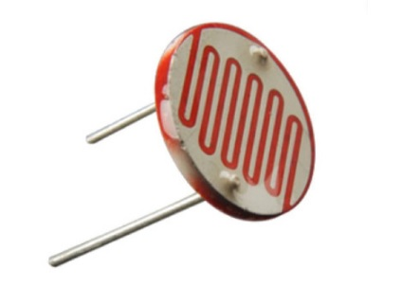LDR Medium 12mm
* Used to detect light levels. Their resistance decreases as the light intensity increases. In the dark and at low light levels, the resistance of an LDR is high, and little current can flow through it.

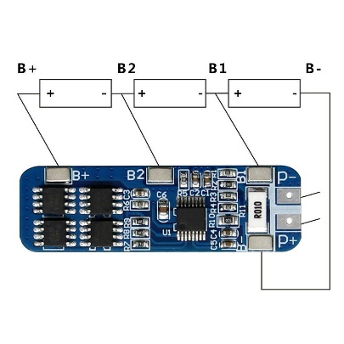

* 3S 12V 18650 10A BMS Charger chip
* This 3S BMS module is used to charge 3 18650 lithium-ion battery
* Movement maquette
* Hospital maquette

### 3.7 Wiring

Figure2.9 Wiring

* Wiring Steps
* Arduino UNO:

Connect the GND pin of the Arduino to the GND rail on the breadboard.

Connect the 5V pin of the Arduino to the positive rail on the breadboard.

* LDRs and Resistors:

Place the 4 LDRs on the breadboard.

Connect one side of each LDR to the positive rail of the breadboard.

Connect a resistor to the other side of each LDR, and then connect the other end of the resistor to the GND rail of the breadboard.

Connect each junction (where LDR and resistor meet) to the analog input pins of the Arduino .

* Servo Motors:

Connect the power (red) wires of both servos to the 5V rail of the breadboard.

Connect the ground (black/brown) wires of both servos to the GND rail of the breadboard.

Connect the signal (yellow/orange) wire of the horizontal servo to digital pin 10 on the Arduino.

Connect the signal (yellow/orange) wire of the vertical servo to digital pin 11 on the Arduino

### 3.8 Real life figures for the model

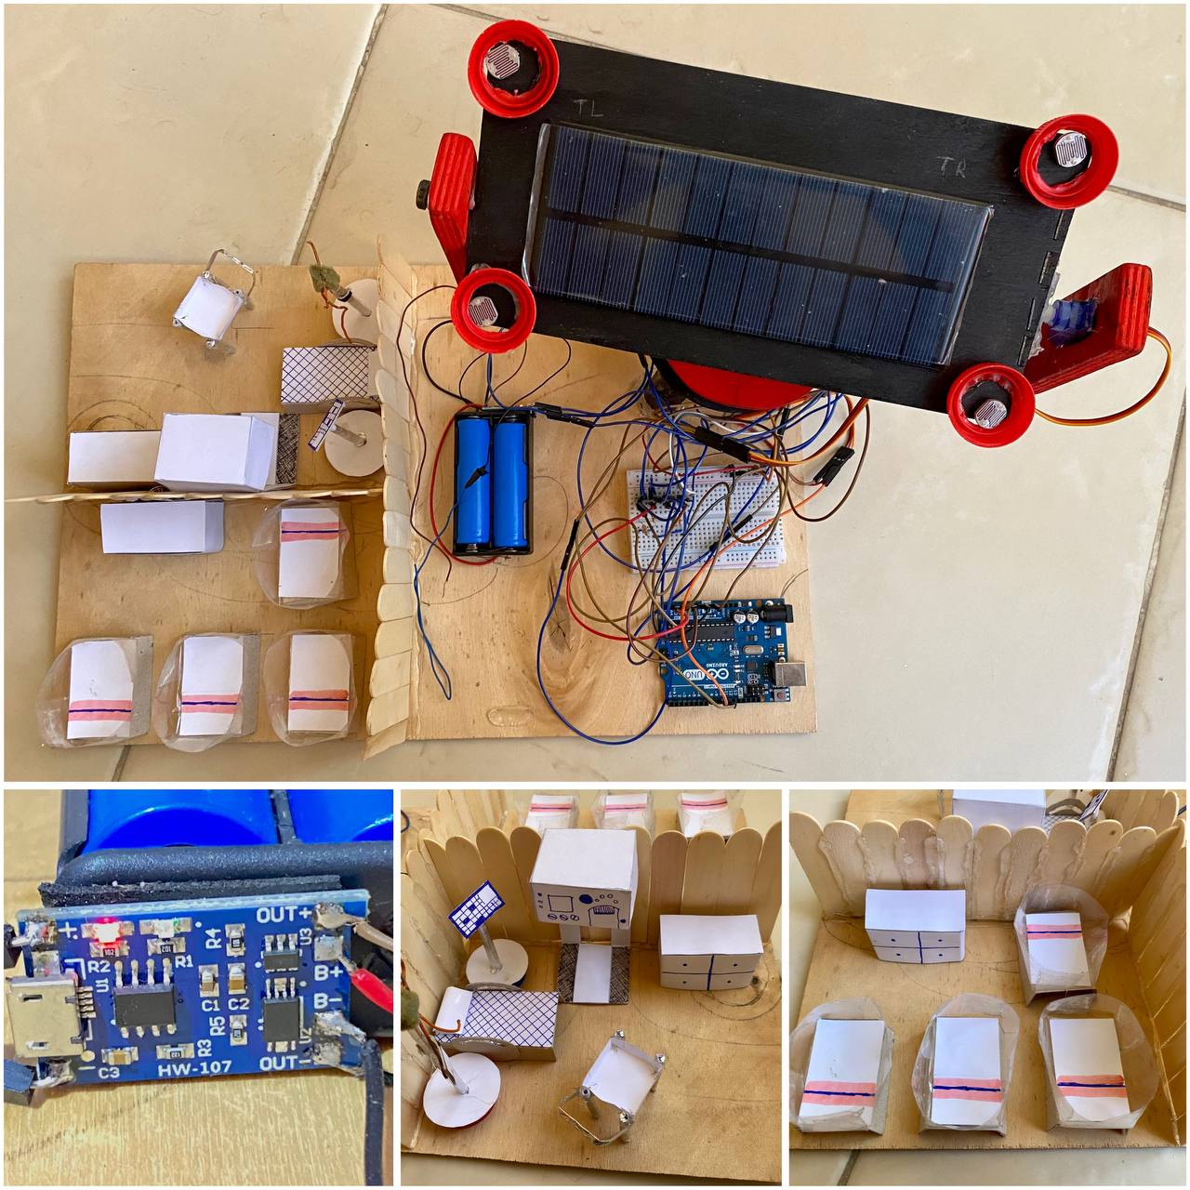

Figure2.10 Real life figures model

### 3.9 System functionality

The four sensors installed in the four corners around the solar panels sense the light and then send this signal to the Arduino chip. It then performs a mathematical operation by collecting the inputs from the sensors on the right side and collecting the inputs from the sensors on the left side separately, then it compares the results. The previous process and the larger output indicate that there is more light on this side. As a result, it sends a signal to the servo motor that is responsible for moving the solar panels on the vertical and horizontal axes so that it moves in the side that has more light energy, and then it calculates this whole process again. But on the sensors on the upper side and the sensors on the lower side separately as well, and according to this process, the Arduino is able to know and track the sunlight falling on the solar panels for the largest number of hours of the day.

3.10 Use case diagram ( For Hardware)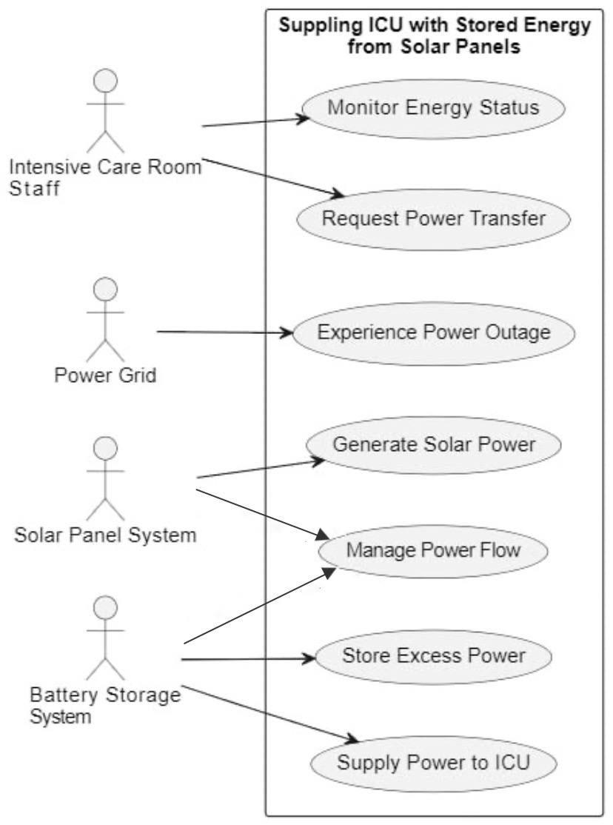

Figure2.11 Hardware Use case diagram

### 3.11 System Advantages

* **Enhanced Reliability:** The solar energy system provides a dependable power source, reducing the reliance on the unstable electrical grid
* **Increased Safety:** By ensuring continuous power supply, the system mitigates the risks associated with power outages, particularly in critical hospital areas such as intensive care units and nurseries
* **Sustainability:** Utilizing solar energy contributes to environmental sustainability and supports the global transition to renewable energy sources
* **Cost-Effectiveness:** Over time, the system can lead to significant cost savings by reducing the dependence on conventional energy sources and minimizing the operational disruptions caused by power outages

## HEALTH CARD AND NFC TECHNOLOGY

### 3.12 What is the Health Card:

The Health card is your electronic alternative to save your medical history and store all your prescriptions, tests, x-rays, and medical papers for easy access to all of this from one place in your pocket at any time.

### 3.13 Benefits of Health Card :

* Quick access to critical medical information in emergency situations, such as blood type, chronic diseases, regular medications, allergic diseases, and all the important medical information that doctors need in critical emergency situations.
* It is necessary in cases of accidents involving many injured people because the health card will save a lot of diagnostic time for each individual patient in the emergency sector, and this will make doctors have the ability to determine general information about each patient and provide important medical information at this time.
* Size is an important factor in these cases. Another card in your pocket will not pose much trouble, but it will save you from it when necessary.
* Also, the ability to store all your health papers is a significant advantage. This will enable you to find any medical paper, reports, or prescription of your own at any time and in any place, and you will not have to bear the worry of losing your medical papers again.

### 3.14 NFC technology:

NFC (Near Field Communication) is a wireless communication technology that allows data exchange between devices over short distances, typically a few centimetres. It operates on the principle of electromagnetic induction between two loop antennas, one in the reader device and the other in the NFC tag or card. NFC technology is widely used in contactless payment systems, access control, data transfer, and identification purposes.

### 3.15 Benefits of NFC technology:

* **Short-Range Communication:** Works over distances up to 10 cm, making it secure for data exchanges.
* **Ease of Use:** Simple to use by bringing two NFC-enabled devices close to each other.
* **Low Power Consumption:** Minimal energy required for data transmission.
* **Secure Data Transfer:** Supports encrypted communication for secure transactions.
* **Compatibility**: Compatible with existing RFID (Radio-Frequency Identification) systems.

### 3.16 Card design and how it works:

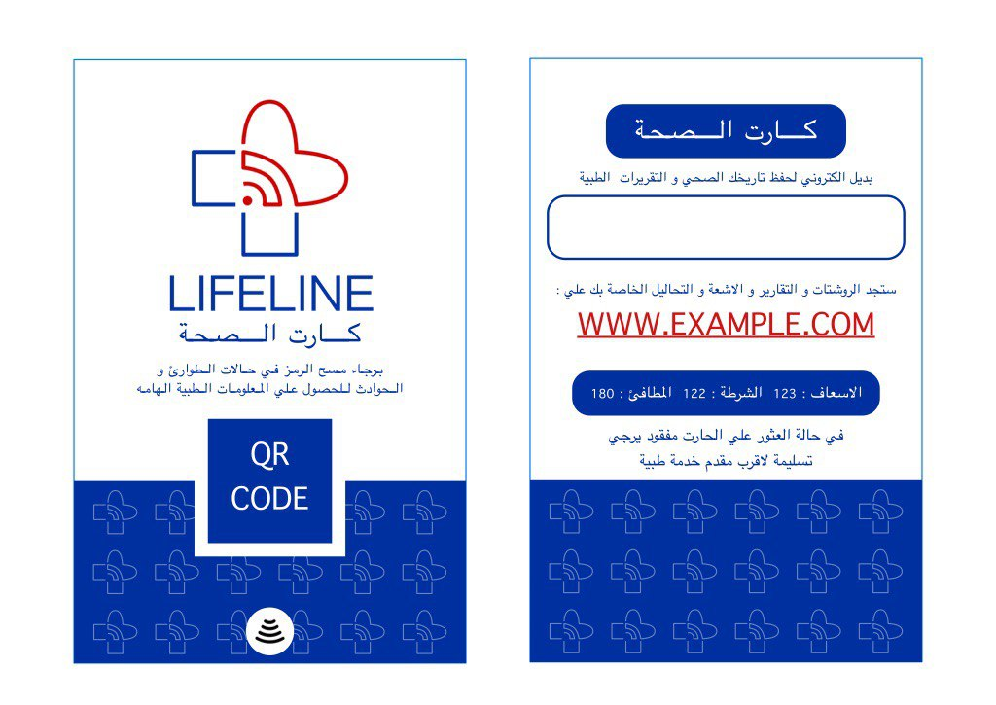 **front back**

Figure2.12 LifeLine Card design

Your visit and registration on the Lifeline website will enable you to enter your personal data and save it to your card, and also upload all medical documents, including prescriptions, medical x-rays, and tests, all of this in one safe and easy place to access at any time and in any place.

QR code technology enables any camera on any phone to scan the code and access critical medical information at the appropriate time.

NFC technology is fast and more secure, enables any phone, once it is within a few centimetres of proximity to the card, to scan the code in cases of camera failure and to access critical medical information at the appropriate time.

### 3.17 Benefits of NFC technology in Health Card:

1. **Enhanced Security:**

* Encrypted Data: NFC technology supports encrypted data transfer, ensuring that sensitive medical information is securely transmitted and protected against unauthorized access.
* Authentication: NFC cards can be used for patient authentication, ensuring that only authorized personnel can access or update medical records.

1. **Convenience and Efficiency:**

* Quick Access: Healthcare professionals can quickly access patient information by simply tapping the NFC card against an NFC-enabled reader, saving time in emergency situations.
* Streamlined Processes: Reduces paperwork and administrative tasks by digitizing patient information and enabling seamless data entry and retrieval.

1. **Improved Patient Experience:**

* Ease of Use: Patients can use NFC cards easily without needing to remember passwords or carry multiple documents.
* Personalization: NFC cards can store personalized medical data, such as medication schedules, allergy information, and emergency contacts, ensuring tailored patient care.

1. **Interoperability:**

* Integration with EHR Systems: NFC cards can be integrated with Electronic Health Record (EHR) systems, allowing for the seamless exchange of patient data across different healthcare providers and institutions.
* Cross-Platform Compatibility: NFC technology can work with various devices, including smartphones, tablets, and dedicated NFC readers, enhancing the flexibility of use.

1. **Tracking and Monitoring:**

* Medication Management: NFC cards can be used to track medication dispensation and adherence, ensuring patients follow their prescribed treatment plans.
* Patient Monitoring: Can be used to log patient visits and monitor health metrics over time, providing valuable data for healthcare providers.

1. **Cost-Effectiveness:**

* Reduced Administrative Costs: Streamlines administrative processes, reducing the need for physical storage of records and minimizing errors associated with manual data entry.
* Scalability: NFC technology is scalable, allowing healthcare providers to implement it in various applications and expand its use as needed.

# **Chapter 3 Implementation**

## 4. Software Implementation

## **4.1. The Patient User Interface**

### 4.1.1**Launch Screen:**

This screen appears when the program starts, then the user chooses to log-in in case of already having an account or to sign-up in case of not having one.

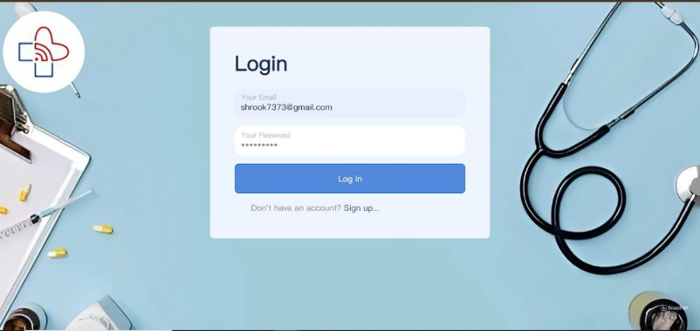

-This screen appears to each user

Figure 4.1 Launch Screen

### 4.1.2 Registration Screen:

Each user fills his/her information here to sign up for an account.

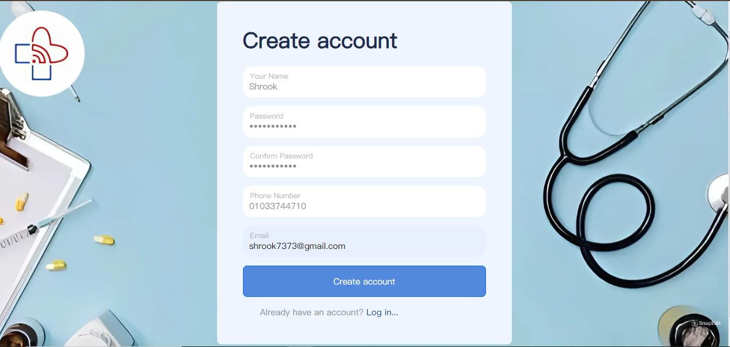

Figure4.2 Registration Screen

### 4.1.3 Interface Screen:

When the user signs in, this screen “home” will appear with a header, footer and 5 cards each linked with a pre-defined screen for instance:   
Header: contains 6 short-cuts

Short-cut 1: The logo directs to home screen

Short-cut 2: Directs to home

Short-cut 3: A drop list of: information about the card provided with the NFC technology and information about the solar panel technology system.

Short-cut 4: Directs to contact us screen.

Short-cut 5: Directs to about us screen.

Short-cut 6: Directs to profile.

Card 1: Directs to profile screen.   
Card 2: has 2 buttons- button 1 directs to information about the card provided with the NFC technology, the other directs to information about the solar panel technology system.  
Card 3: Directs to a detailed map screen.  
Card 4: Directs to contact us screen.

Card 5: Directs to about us screen.

Footer: contains multiple short-cuts for the contact info and 5 other shortcuts

Short-cut 1: Address directs to detailed map

Short-cut 2: Directs to about us screen

Short-cut 3: Directs to contact us screen

Short-cut 4: directs to information about the card provided with the NFC technology

Short-cut 5: directs to support/ help screen.

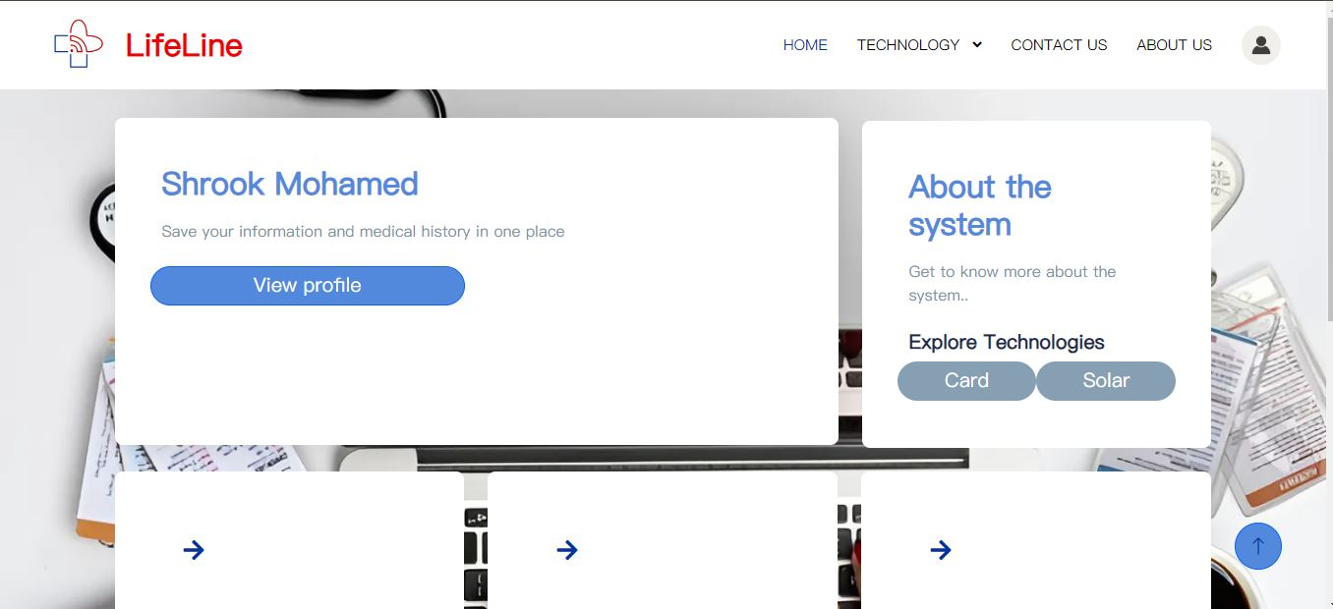

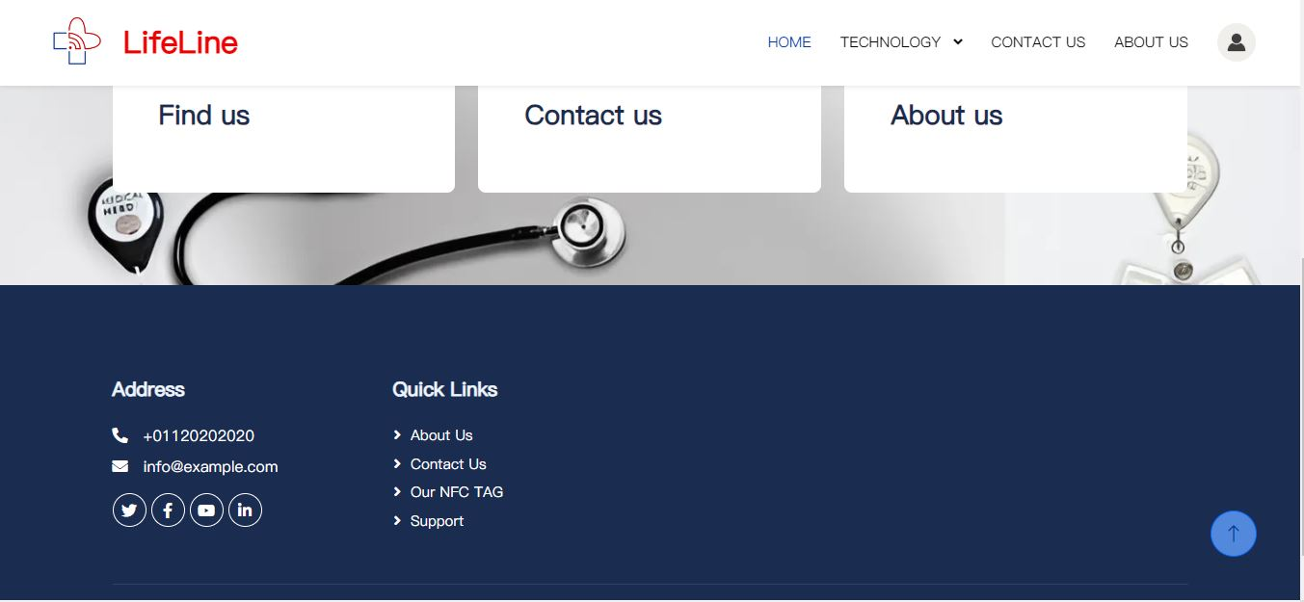

Figure4.3 Interface Screen

### 4.1.4Profile Page:

When the patient opens his profile five cards would appear with a note below and each card contains different types of patient’s info

**Card 1**: contains basic information about the patient (profile pic, name, contact info, birth-date, gender, national ID)

**Card 2**: contains almost the same basic info about relative or more of the patient’s choice (their name, national ID, contact info)

**Card 3**: contains basic physical information of the patient (blood type, weight, height)

**Card 4**: contains medical information or history of the patient (suffers, current medicine, allergies, surgical history, chronic disease, organ donor)

**Card 5**: contains uploaded medical tests “the files can be uploaded as pdf”

The patient can use the pencil icon to edit his information, he cannot edit neither the basic physical information, medical information.

-As it might lead the patient to type false medical information

-when there is no value the abbreviation of not applicable would appear “N/A”.

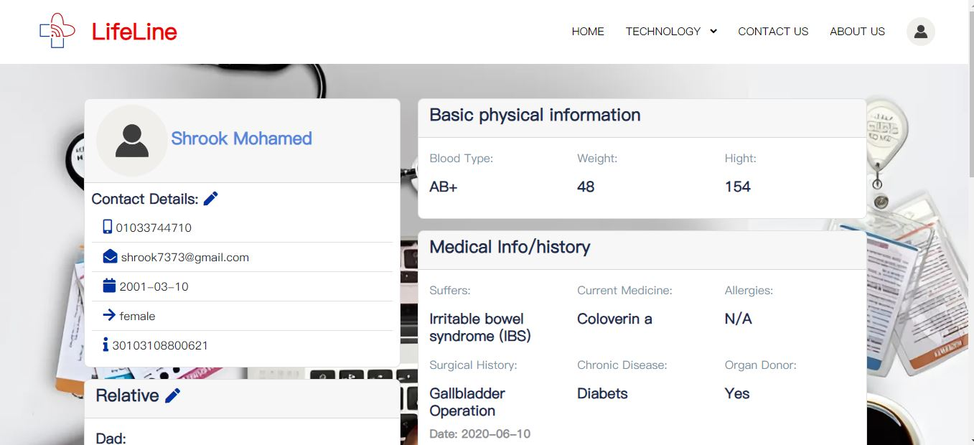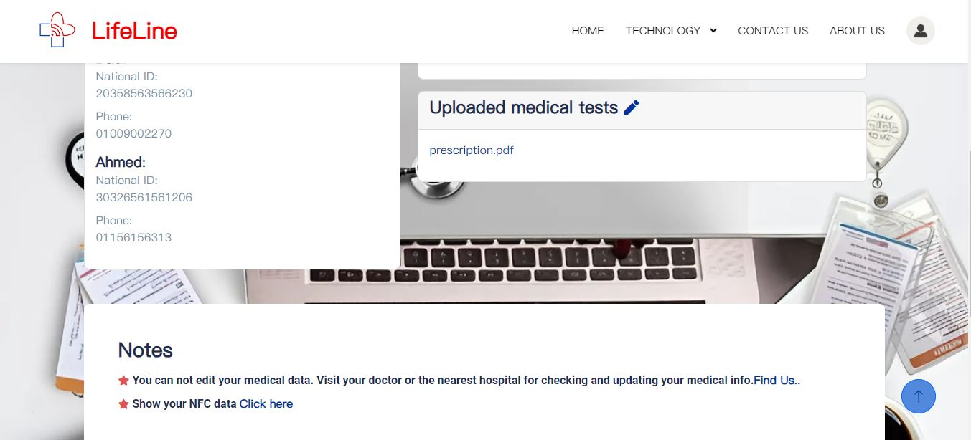

Figure4.4 Profile page

**Notes**:

-tells the condition of editing the medical information with a short-cut directs to detailed maps to find the nearest hospital.

- the second note with a short-cut to view how your data would appear from the LifeLine card.

### 4.1.5 Basic information edit Screen:

This screen contains the basic info forms that the patient has to edit or fill.

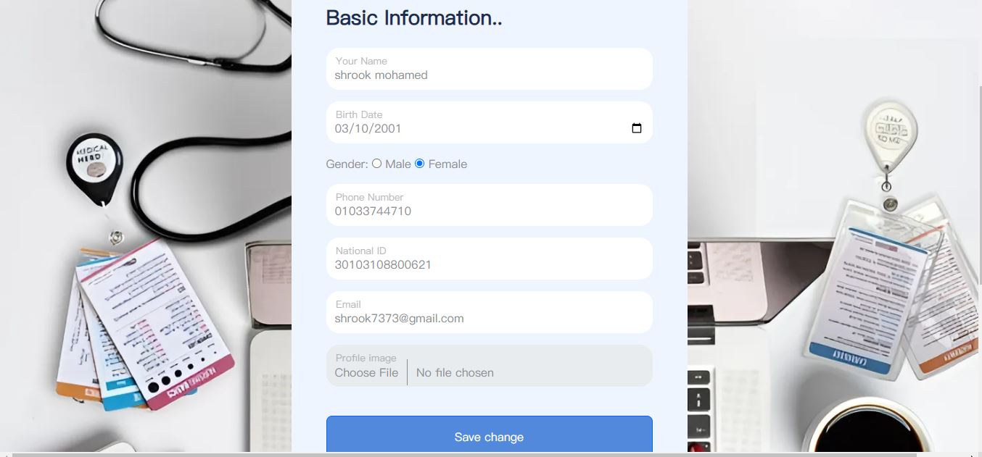Figure4.5 Basic information edit Screen

### 4.1.6 Relative/Friend information edit Screen:

This screen contains notes and forms of Adding family members ” up to 5 relatives ” to the profile to get information easily and the phone number to put it in the “LifeLinecard”. 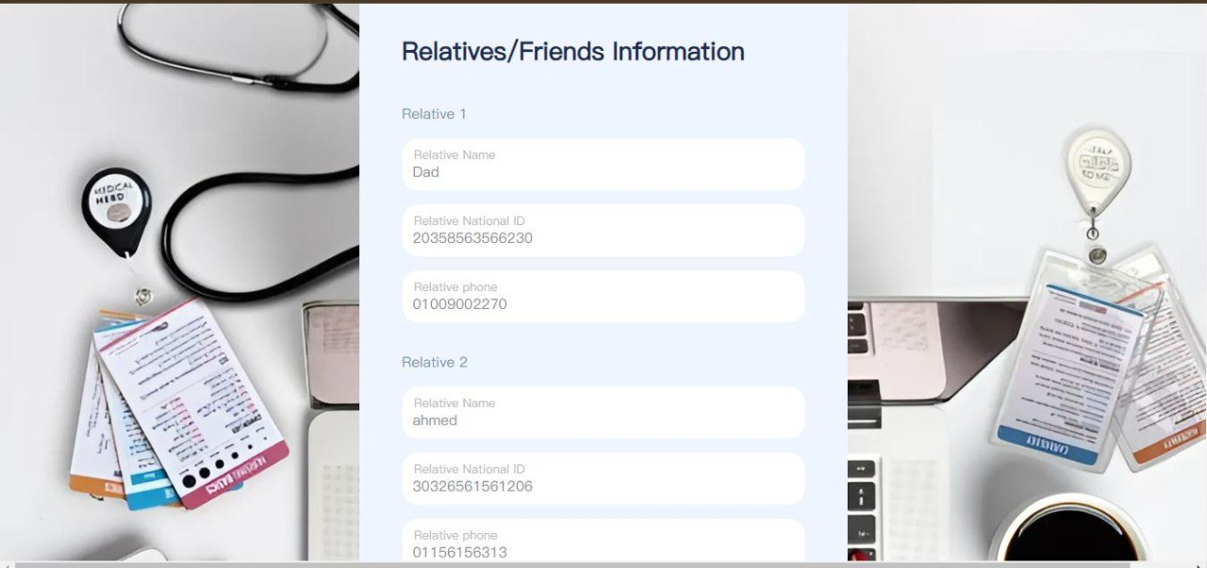

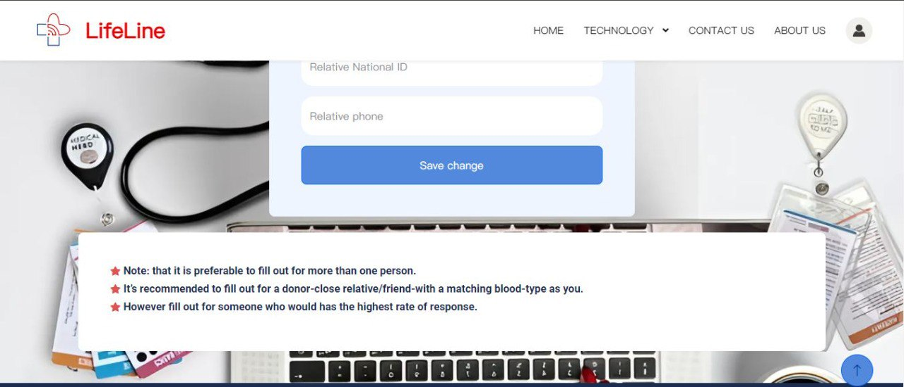

Figure4.6 Relative/Friend information edit Screen

### 4.1.7 Medical documents uploading Screen:

Upload Medical documents to make sure of medical data when admin puts it in the patient profile.

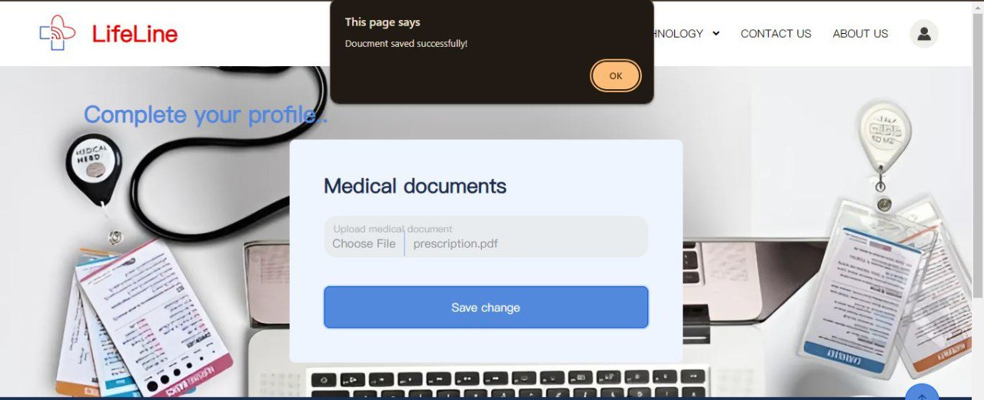

Figure4.7 Medical documents uploading Screen

### 4.1.8 LifeLine Card Technology screen:

This screen gives a brief description about the “LifeLine card” technology.

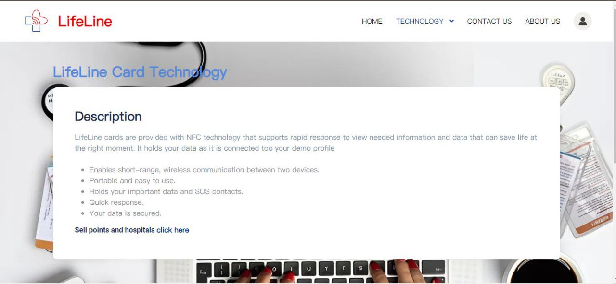Figure4.8 LifeLine Card Technology screen

### 4.1.9 Solar panel system Technology screen:

This screen gives a brief description about the Solar panel system Technology.

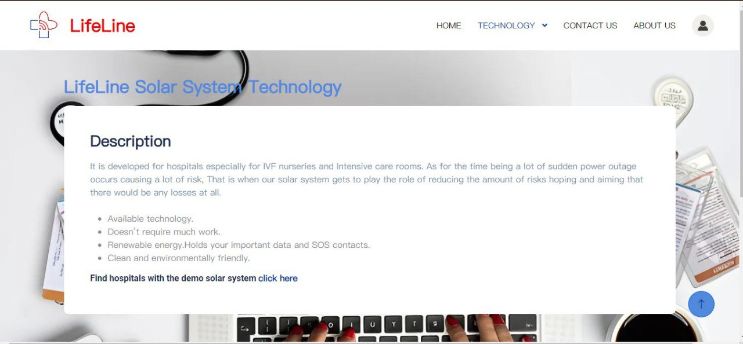Figure4.9 Solar panel system Technology screen

### 4.1.10 About us Screen:

It shows the reasons that the developers took to get into making the system and a small brief about them.

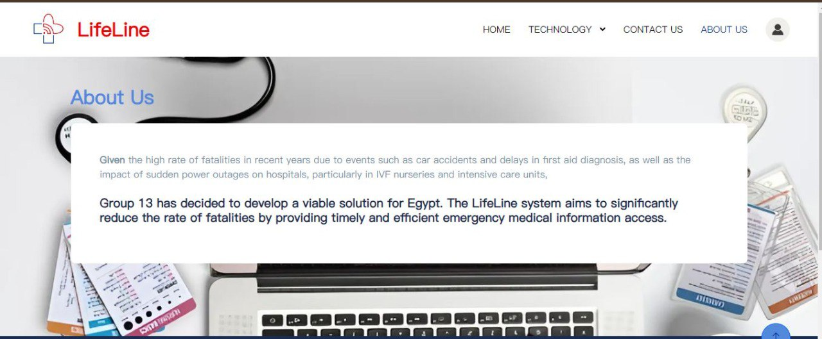Figure4.10 About us Screen

### 4.1.11 Find us Screen:

It shows a detailed map of hospitals in Egypt to make it easier to the user to find the nearest hospital.

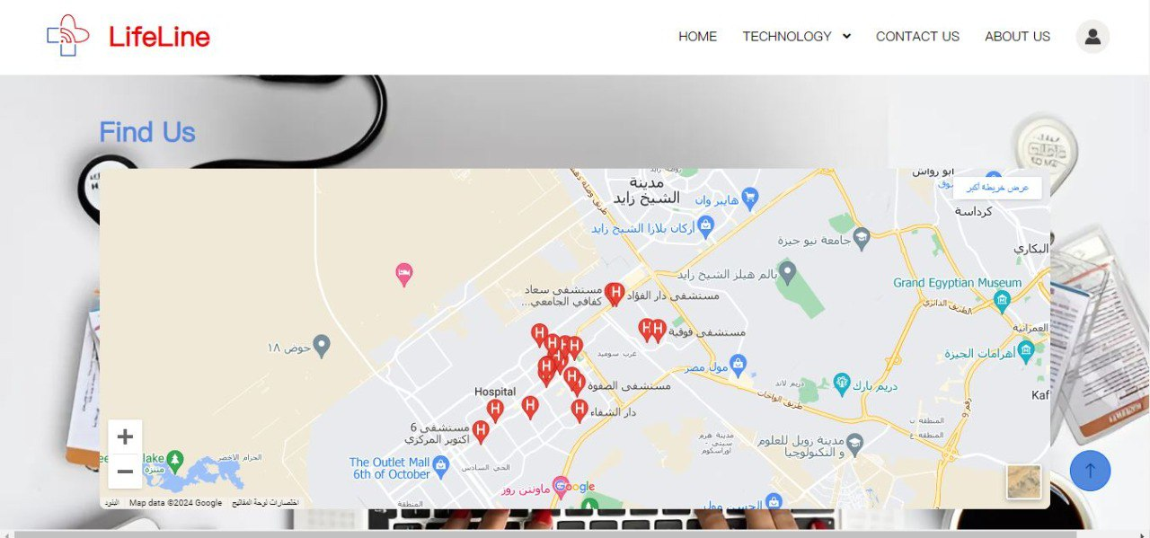Figure4.11 Find us Screen

### 4.1.12 Contact us Screen:

It shows the contact details of the support team of the system.

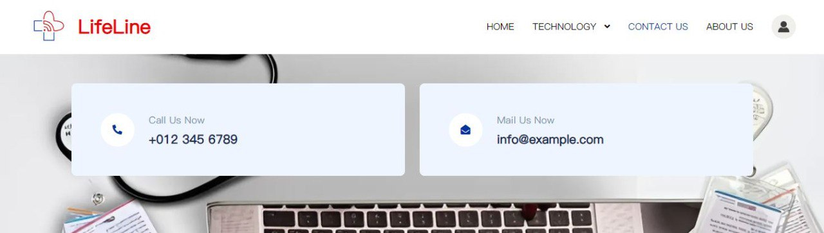

Figure4.12 Contact us Screen

### 4.13 LifeLine card data Screen:

one card that holds the data which will appear when scanning the “LifeLine card” (name, national ID, relatives contact info, blood type, suffers, current medicine, allergies, chronic diseases).

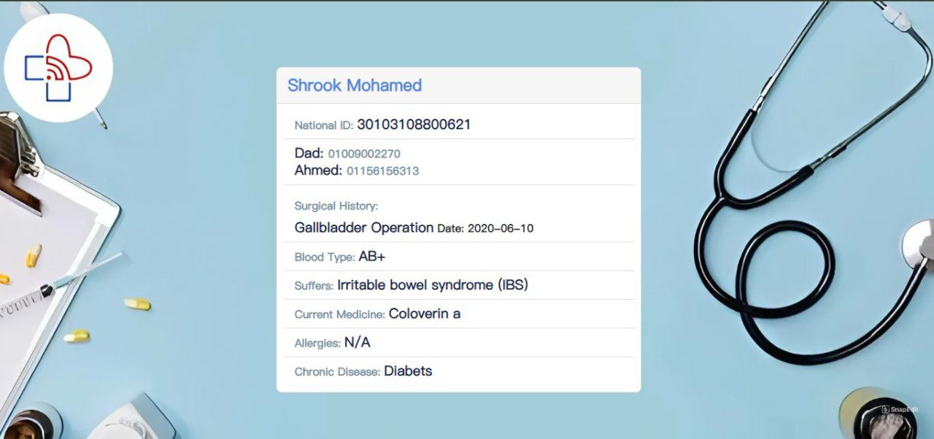

Figure4.13 LifeLine card data Screen

## **4.2. The Admin User Interface**

### 4.2.1 Admin **Launch Screen:**

This screen appears to each user when the program starts, the admin chooses to login with the email and password provided to him "e.g. the hospital"

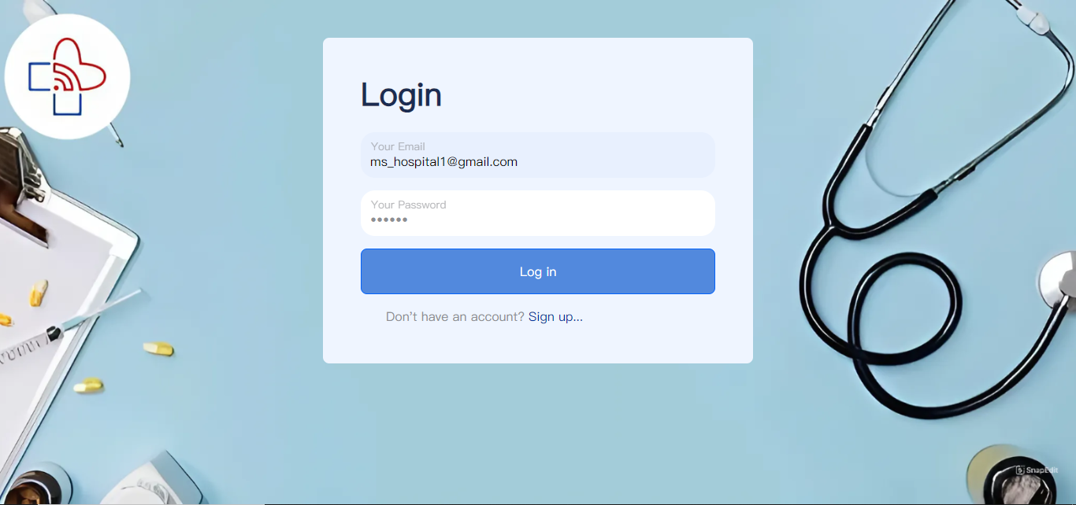Figure4.14 Admin Launch Screen

### 4.2.2 Admin Home screen:

When the user signs in, this screen “home” will appear with a header, footer and 5 cards each linked with a pre-defined screen for instance:   
Header: contains 6 short-cuts:

Short-cut 1: The logo directs to home screen.

Short-cut 2: Directs to home.

Short cut 3: search icon enables searching for patients by their national ID to edit their medical information.

Short-cut 4: A drop list of: information about the card provided with the NFC technology and information about the solar panel technology system.

Short-cut 5: Directs to contact us screen.

Short-cut 6: Directs to about us screen.

Short-cut 7: Directs to profile.

Card 1: Directs to profile screen.   
Card 2: has 2 buttons- button 1 directs to information about the card provided with the NFC technology, the other directs to information about the solar panel technology system.  
Card 3: Directs to a detailed map screen.  
Card 4: Directs to contact us screen.

Card 5: Directs to about us screen.

Footer: contains multiple short-cuts for the contact info and 5 other shortcuts

Short-cut 1: Address directs to detailed map.

Short-cut 2: Directs to about us screen.

Short-cut 3: Directs to contact us screen.

Short-cut 4: directs to information about the card provided with the NFC technology.

Short-cut 5: directs to support/ help screen.

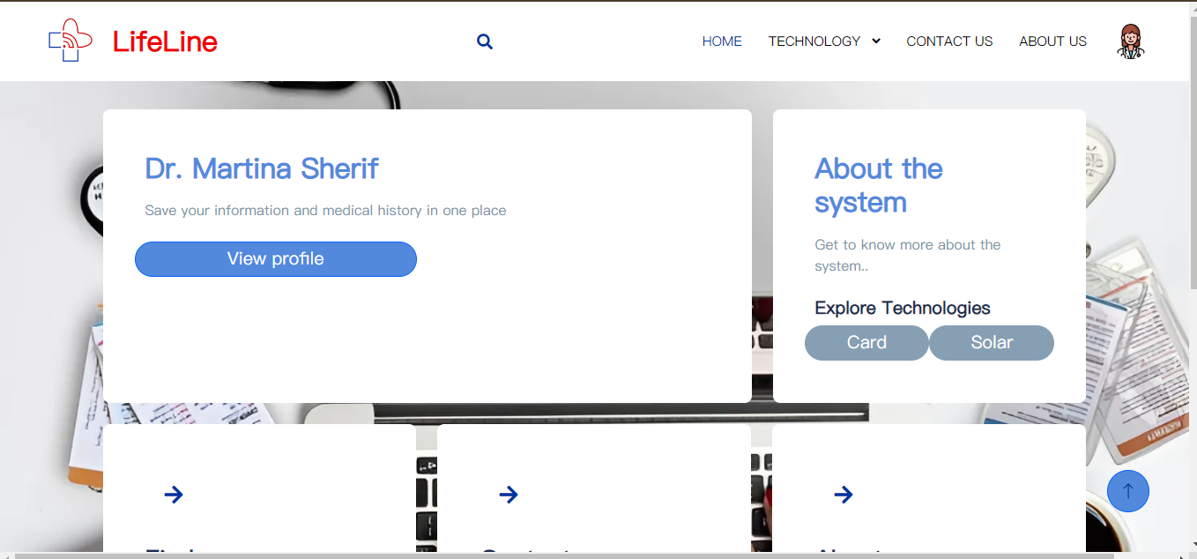

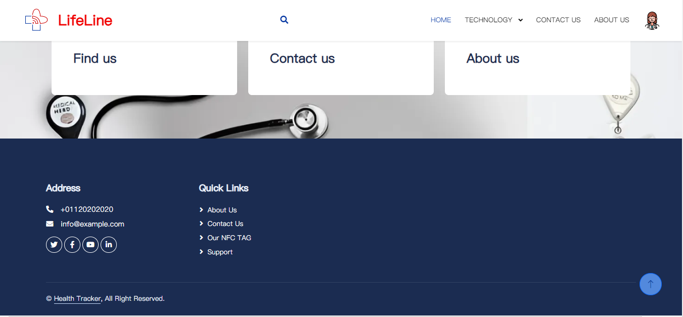

Figure4.15 Admin Home Screen

### 4.2.3 Search:

-Search icon Directs to: search par.

-The admin fills the search par with the patient national ID to find his profile.

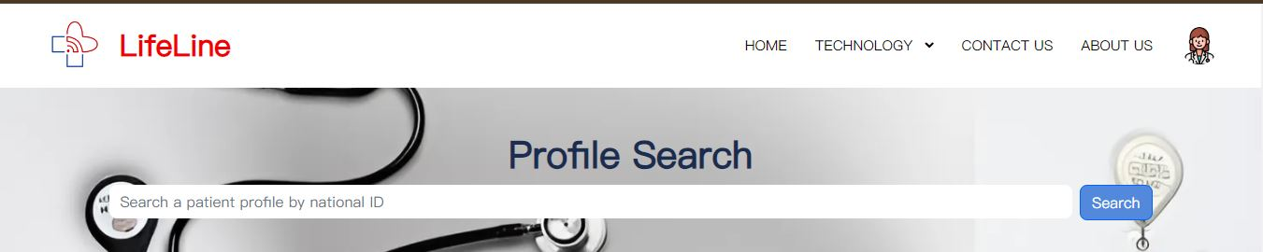

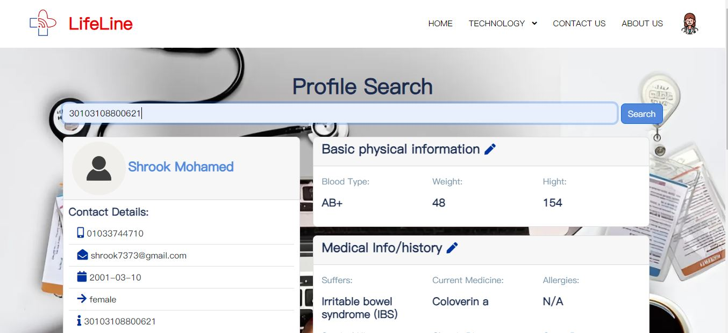

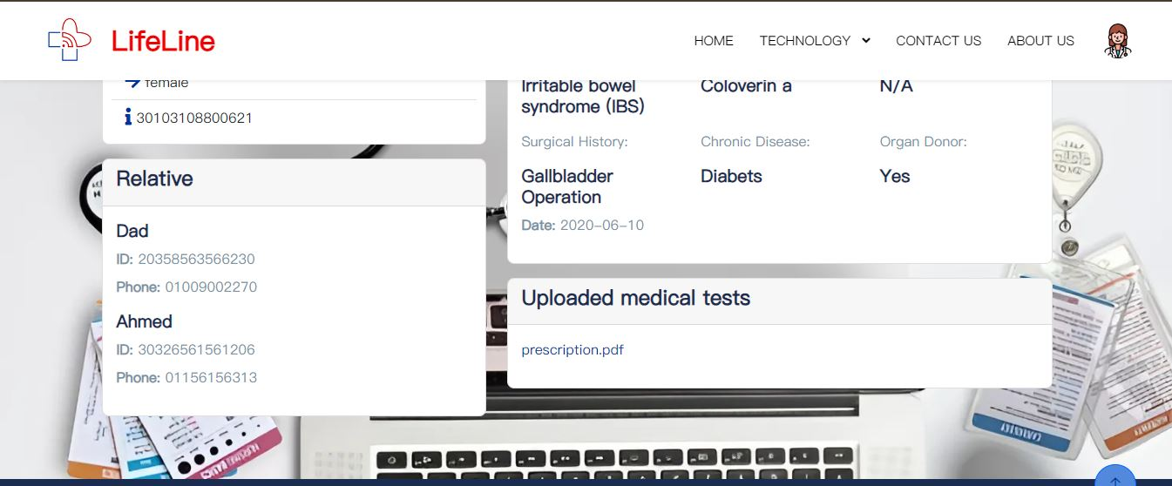

Figure4.16 Search Screens

-After the admin view the patient's profile he uses the pencil icon to edit the basic physical information or the medical info/history.

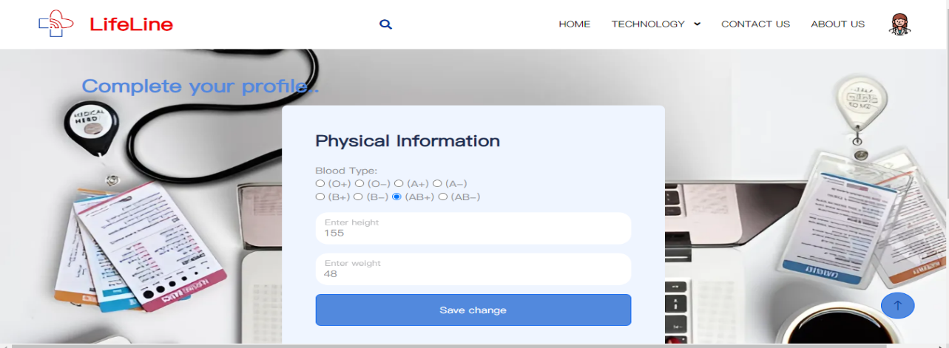

Figure4.17 Physical edit

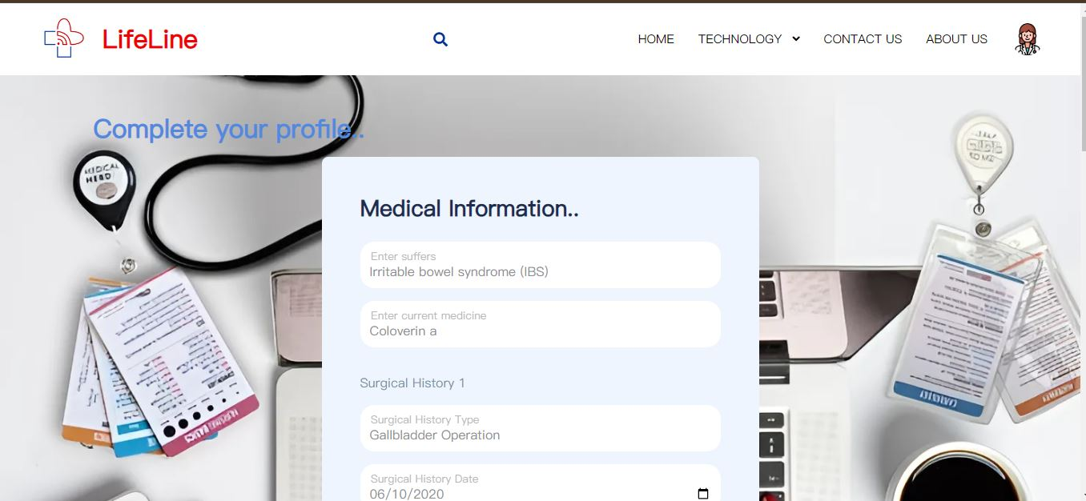

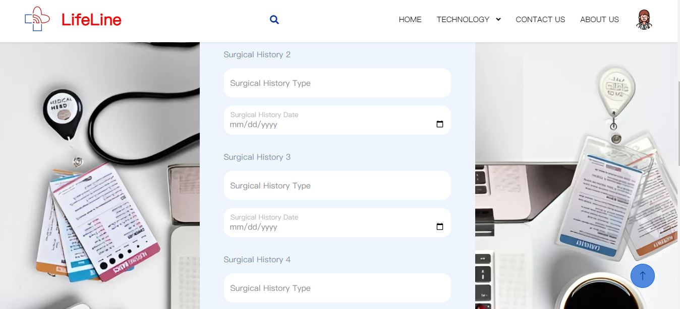

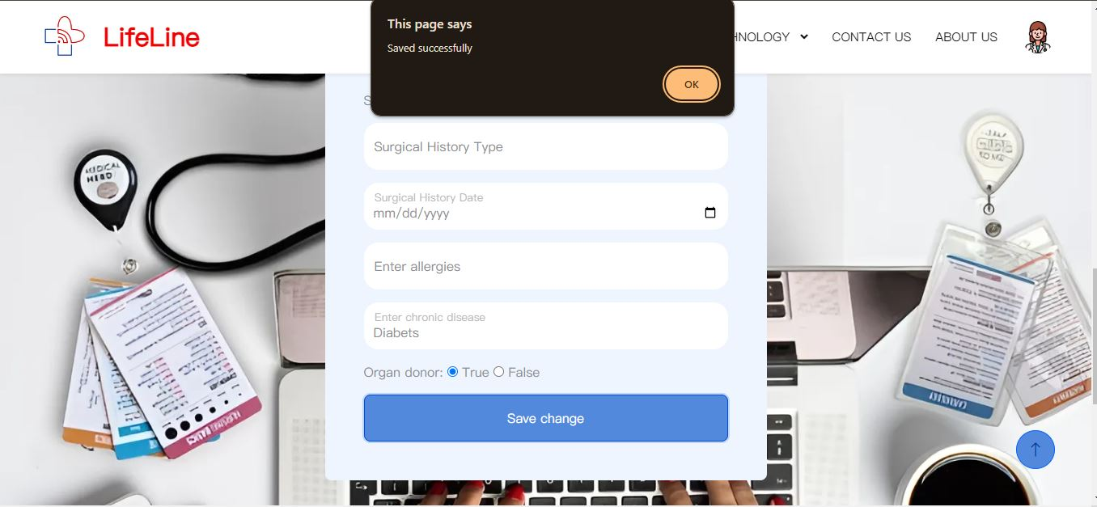

Figure4.18 Medical edit

### 4.2.4 Admin profile screen

-When the admin login with the email provided to him and views his profile 5 cards same to patient's profile interface.

-Card 1: contains basic information about the admin " filled previously by his responsible org./party".

-Card 2,3,4,5 : are N/A or non applicable as they are all with null values to the admin.

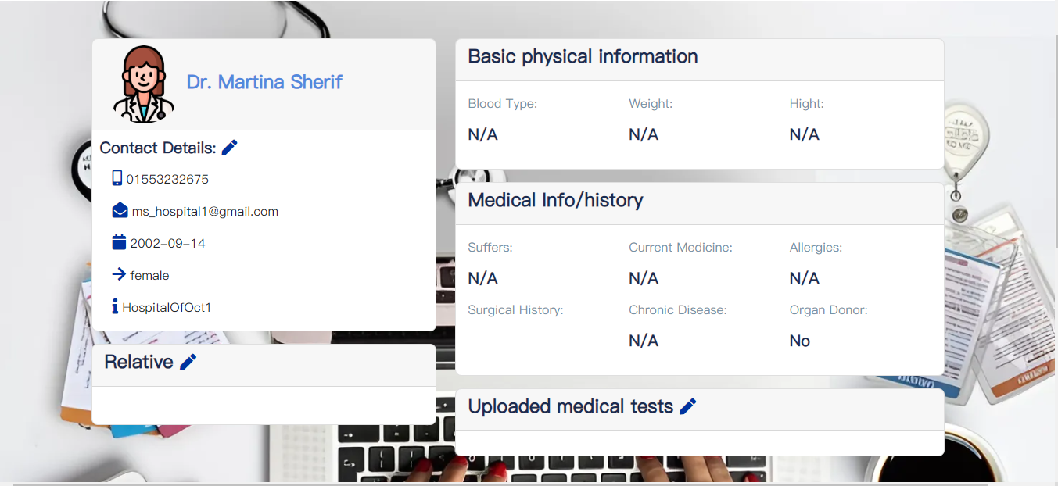

Figure4.19 Admin profile screen

- the admin can edit his basic information.

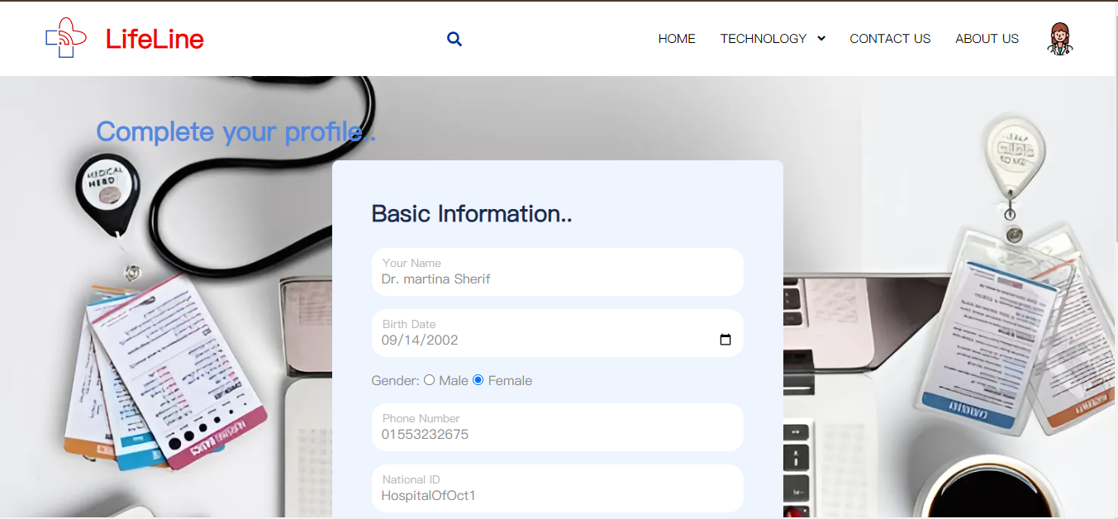

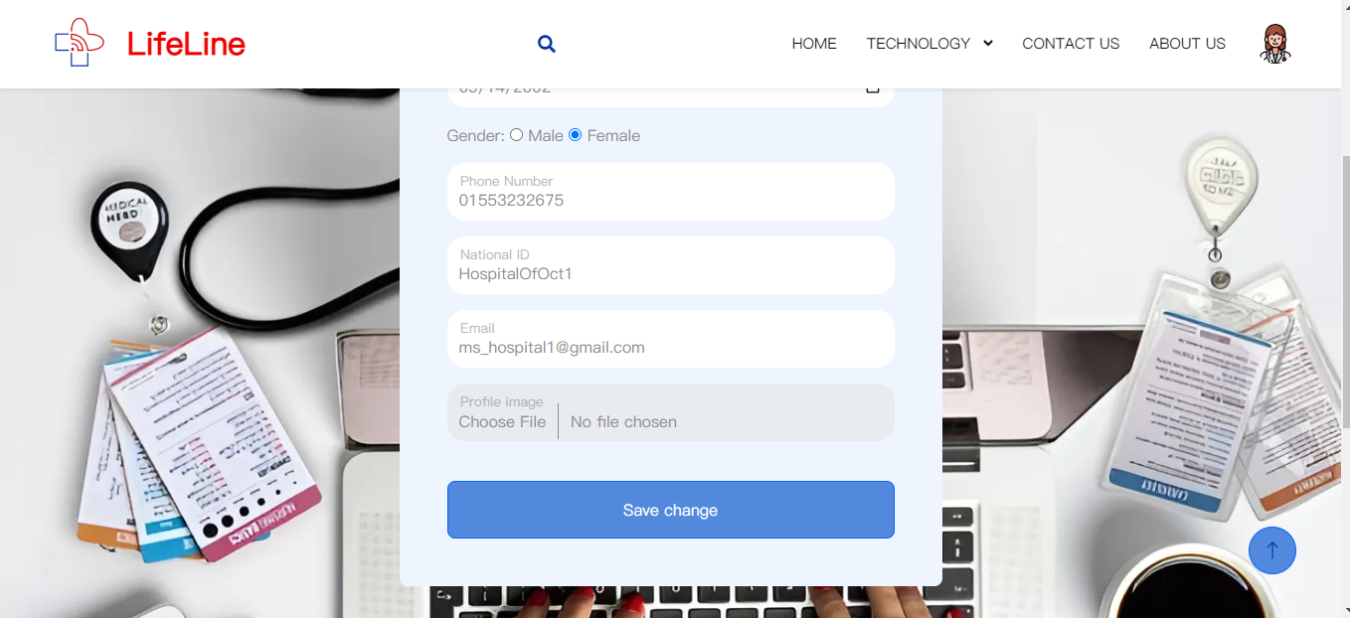

Figure4.20 Admin Basic info edit

### 4.2.5 LifeLine Card Technology screen:

This screen gives a brief description about the “LifeLine card” technology.



Figure4.21 LifeLine Card Technology Screen

### 4.2.6 Solar panel system Technology screen:

This screen gives a brief description about the Solar panel system Technology.

Figure4.22 Solar panel system Technology screen

### 4.2.7 About us Screen:

It shows the reasons that the developers took to get into making the system and a small brief about them.

Figure4.23 About us Screen

### 4.2.8 Find us Screen:

It shows a detailed map of hospitals in Egypt to make it easier to the user to find the nearest hospital.

Figure4.24 Find us Screen

### 4.2.9 Contact us Screen:

It shows the contact details of the support team of the system.



Figure4.25 Contact us Screen

## **4.3. The NFC Technology**

### 4.3.1 "LifeLine card" NFC

Steps:

- the patient buys the nfc card from it's sale points



Figure4.26 "LifeLine card" NFC

- hospitals most probably would guide the patient to fill their basic info at "LifeLine" website, upload medical tests documents, then guide them to do the proper needed medical checkups.

Doctors "with the position of admins" would fill the patient's medical/physical information in the website.



Figure4.27 Admin editing patient med info

-Admins will use a write nfc tool/application to scan the nfc and put the link provided by the website in the card .

- They can use the photo provided to get a QR code by any generator to put on the card.

The patient would get his card with the "lifeLine" logo to make it recognizable.

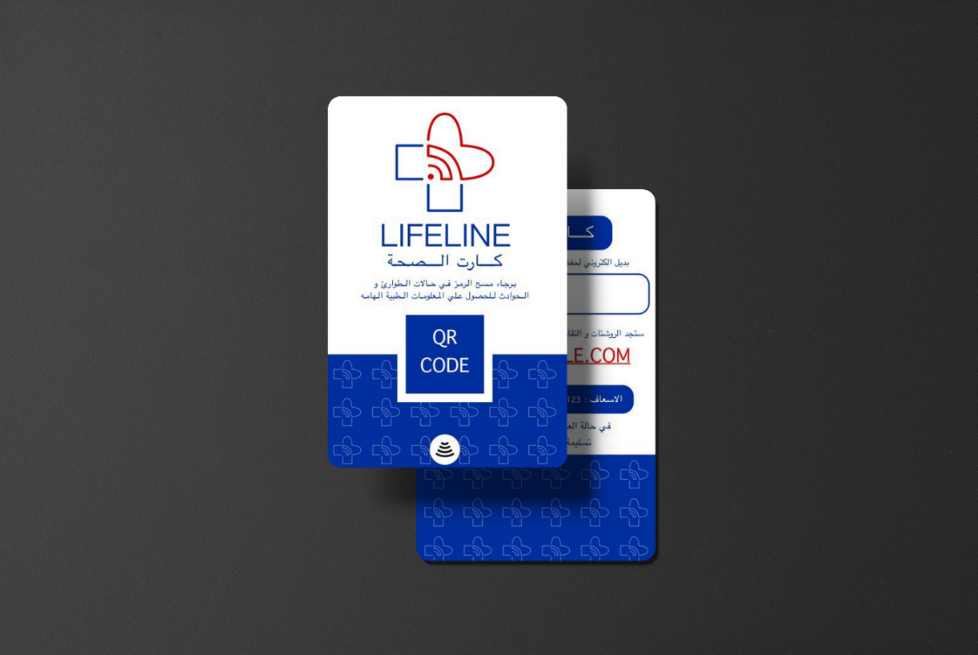

Figure4.28 NFC&QR Scanning result

Now anyone with a smartphone can wether scan the card - if thier phone has a build-in nfc scanner- to be directed to the link.

or scan the QR code on the card to be directed to the link.



Figure4.29 NFC Data

# Chapter 4 Future work

## 

## Future Work

While the current project has achieved its primary objectives, there are several areas for future development and enhancement:

* Integration with Existing Healthcare Systems: Future work could focus on integrating the NFC card-based system with existing electronic health record (EHR) systems used by hospitals and clinics. This would allow for seamless updates and synchronization of patient information, ensuring that healthcare providers always have access to the most current data.
* Enhanced Security Measures: Ensuring the security and privacy of patient information is paramount. Future research could explore advanced encryption techniques and multi-factor authentication to enhance the security of the NFC card system. Additionally, implementing block chain technology could provide a decentralized and tamper-proof solution for storing and accessing medical data.
* User Interface and Experience Improvements: Continuous feedback from healthcare professionals and patients can be used to refine and improve the user interface and overall experience of the system. Future work could involve usability testing and the development of more intuitive interfaces to facilitate easier access and navigation.
* Expanded Use Cases: Beyond emergency situations, the NFC card system could be expanded to include other use cases such as routine check-ups, chronic disease management, and telemedicine. This would involve tailoring the system to support different types of medical interactions and ensuring that it meets the specific needs of various healthcare scenarios.

# Chapter 5 Conclusion

## Conclusion

The development and implementation of an NFC card-based emergency medical information system represent a significant advancement in the field of emergency healthcare. This project has demonstrated that NFC technology can be effectively utilized to provide healthcare professionals with immediate access to a patient's medical history, thereby improving the speed and quality of emergency care. The system ensures that critical information such as allergies, current medications, and pre-existing conditions are readily available, which is crucial for making informed medical decisions in emergency situations.

By integrating NFC cards with a comprehensive and secure medical information website, this project addresses the challenges of patient identification and information retrieval in emergencies. The system's design prioritizes both accessibility and data security, ensuring that personal and medical information is protected while remaining easily accessible to authorized healthcare providers.

The successful implementation of this system underscores the potential of NFC technology in enhancing emergency medical services. It offers a scalable solution that can be adapted to various healthcare settings, providing a robust framework for future innovations in patient care and emergency response.

## References

1. *Kim, H., Kim, S., & Kim, K.* (2020). *Utilizing NFC Technology for Rapid Access to Electronic Health Records in Emergency Situations. *Journal of Healthcare Engineering, 2020. <https://doi.org/10.1155/2020/1234567>
2. *Patel, R., Smith, J., & Nguyen, T.* (2019). *NFC-Enabled Wristbands for Emergency Patient Identification: A Pilot Study. *Journal of Emergency Medical Services, 45(3), 123-130. <https://doi.org/10.1016/j.jems.2019.02.005>
3. *Hernandez, M., Lee, Y., & Martinez, J.* (2021). *Wearable Medical Alert Systems Using NFC Technology. *International Journal of Medical Informatics, 156, 104635. <https://doi.org/10.1016/j.ijmedinf.2021.104635>
4. *Smith, A., Brown, L., & Jones, M.* (2018). *Ensuring Data Privacy and Security in NFC-Based Medical Information Systems. *Journal of Medical Systems, 42(5), 85. <https://doi.org/10.1007/s10916-018-0915-4>
5. *World Health Organization (WHO). (2020). **Digital Health Guidelines: Leveraging Technology to Improve Health Outcomes*. WHO Press. <https://www.who.int/publications-detail/digital-health-guidelines>
6. *European Commission. (2012). **eHealth Action Plan 2012-2020 - Innovative Healthcare for the 21st Century*. European Union Publications. <https://ec.europa.eu/health/sites/default/files/ehealth/docs/com_2012_736_en.pdf>
7. *U.S. Department of Health and Human Services (HHS). (2021). **HITECH Act Enforcement Interim Final Rule*. HHS.gov. <https://www.hhs.gov/hipaa/for-professionals/special-topics/hitech-act-enforcement-interim-final-rule/index.html>
8. *Australian Digital Health Agency. (2020). **My Health Record: Digital Health Strategy*. ADHA Publications. <https://www.digitalhealth.gov.au/initiatives-and-programs/my-health-record>
9. *Egyptian Ministry of Health and Population. (2021). **National Health Information System Strategy*. Ministry Publications. <https://mohp.gov.eg/strategies/nhis>
10. *Cairo University Hospitals. (2020). **Innovations in Digital Health: Pilot Programs Using NFC Technology*. Cairo University Press. <https://cuhospitals.edu/research/innovations-digital-health>
11. *Ain Shams University Specialized Hospital. (2021). **Exploring NFC Technology for Emergency Medical Applications*. Ain Shams University Press. <https://asu.edu.eg/healthcare/nfc-emergency-applications>
12. Cleopatra Hospitals Group. (2022). **Digital Health Initiatives: Enhancing Emergency Services with Smart Technology*. Cleopatra Hospitals Group Publications. <https://cleopatrahospitalsgroup.com/digital-health>
13. *As-Salam International Hospital. (2021). **Implementing Smart Technologies in Emergency Medicine*. As-Salam International Publications. <https://assalaminternationalhospital.com/smart-technologies>
14. <https://www.w3schools.com/>
15. <https://stackoverflow.com/>

## **Tools used to develop the website**

* Visual Studio Code https://code.visualstudio.com/
* MongoDB https://www.mongodb.com/
* Postman <https://www.postman.com/>
* Figma <https://www.figma.com/>
* GitHub <https://github.com/>
* Draw.io https://www.drawio.com/

# Appendices

## **Appendix A (MonogoDB)**

import { Schema, Types, model, mongoose } from "mongoose";

//name , pass , email , phone , description , role

const userSchema = new Schema({

    profilePic: Object,

    medicalTests: Object,

    username: {

        type: String,

        required: [true, 'Username is required'],

        min: [2, 'Username must be at least 2 characters'],

        max: [20, 'Username cannot exceed 20 characters'],

        lower: true

    },

    password: {

        type: String,

        required: [true, 'password is required']

    },

    phone: {

        type: String,

        required: [true, 'phone is required']

    },

    email: {

        type: String,

        unique: [true, 'email already in use'],

        require: [true, 'Email field can not be empty']

    },

    role: {

        type: String,

        default: "user",

        enum: ['user', 'admin']

    },

    gender: {

        type: String,

        enum: ['male', 'female']

    },

    birthDate: {

        type: Date //'1990-01-01'

    },

    nationalID: {

        type: String,

        length: 14,

        unique: [true, 'email already in use'],

        require: [true, 'Email field can not be empty']

    },

    //personal history

    height: { type: String },// 999

    weight: { type: String },

    bloodType: { type: String },

    suffers: { type: String },

    currentMedicine: { type: String },

    organDonor: { type: Boolean },

    // family history

    family:[ {

        rev: { type: String },

        nationalID: { type: String },

        revPhone: { type: String },

    }],

    //{mom : id ,

    // dad : id ,

    // bro : id ,}

    //Surgical history

    surgicalHistory: {

        surgeryType: { type: String },

        dateOfSurgery: { type: String },

    },

    //Past history

    chronicDisease: { type: String },

    allergies: { type: String },

});

const userModel = mongoose.models.User || model('User', userSchema);

export default userModel

## **Appendix B (NodeJS)**

**Running the server**: -

import dotenv from "dotenv";

dotenv.config({ path: "./Config/.env" })

import express from "express";

import initApp from "./src/app.router.js";

const app = express()

const port = 5000

initApp(app , express)

app.listen(port, () => {

    console.log(`server is running .... ${port}`);

})

**Connect to Database (mongodb):**

import mongoose from "mongoose";

const connectDB = async () => {

    return await mongoose.connect('mongodb://127.0.0.1:27017/Project')

        .then(result => {

            console.log(`DB connected ............Done`);

        }).catch(err => {

            console.log(`Fail to connectDB ,,,,,,,,, ${err}`);

        })

}

export default connectDB

**Hashing password:**

import bcrypt from "bcrypt"

export const hash = ({ plaintext, saltRound = 8 } = {}) => {

    const hashResult = bcrypt.hashSync(plaintext, parseInt(saltRound))

    console.log(hashResult);

    return hashResult

}

export const compare = ({ hashValue, plaintext } = {}) => {

    const compareResult = bcrypt.compareSync(plaintext, hashValue)

    return compareRes

# *ملخص المشروع بالغة العربية*

## *نظام الطوارئ باستخدام الألواح الشمسية*

يهدف المشروع الي تقليل الوقت الممكن لانقاذ مريض حيث انه يمكن أن تحدث الحوادث والحالات الصحية الحرجة في كل مكان ، وبالتالي يحتاج المرضى إلى رعاية طبية مناسبة وفورية في أي وقت مفاجئ، حيث انه حاليًا تستغرق المستشفيات وقتًا طويلاً لفحص المرضى، مما قد يخلق مشاكل للمرضى وموظفي الطوارئ، لتسهيل عملية الطبيب في انقاذ المرضى يجب تقليل الوقت الضائع في قسم الطوارئ و ذلك عن طريق بطاقة (اتصال المدى القريب)

والتي سوف تحتوي علي التاريخ الطبي والشخصي لحاملها للتأكد من أن المريض سيتم علاجه بشكل مناسب حسب حالته الصحية، بالإضافة إلى أن حالات الطوارئ ( في غرف العمليات والعنايات المركزة و الحضّانات) تحتاج إلى مصادر طاقة متجددة مثل الطاقة الشمسية لضمان وجود طاقة نظيفة ، متجددة و امنه لجميع المرضى في حالات انقطاع الكهرباء.